 

Open-ALAQS

Quick start user guide

Version 1.0

May 2016

Authors

|  |  |
| --- | --- |
| **Name** | **Company** |
| Dr. Stavros Stromatas | ENVISA,  22 rue Oberkampf,  F-75011 Paris, Tel. + 33 1 71 19 45 86 |

Table of Contents

Introduction 4

How to use this guide 4

Installing Open-ALAQS 5

Quantum GIS 2.12 (Lyon) 5

“OpenLayers” Python Plugin 5

Geographiclib 6

Spatialite 64-bit 7

Open-ALAQS 7

AUSTAL2000 8

Create a new study 9

Import a map 9

Setup a new study 9

Define emission sources 11

Aircraft related Sources 13

Stationary (Non-Aircraft) Sources 15

Emissions inventory 18

Aircraft movements 18

Meteorology 19

Generate emission inventory 20

Calculate emissions & Query results 21

Visualize results 22

Dispersion with Open-ALAQS/AUSTAL2000 22

Test case study: CAEPport 25

Create a new study 26

Add aircraft-related sources 28

Add non aircraft-sources 32

Calculate Taxi-routes 36

Generate Emission Inventory 37

Calculate & Visualize Results 38

Prepare AUSTAL2000 Input Files 40

Run AUSTAL2000 41

Visualize AUSTAL2000 Results 42

Useful Information 44

AUSTAL2000 44

Adjustments made to AUSTAL2000 44

Input data 44

Start of the dispersion calculation 46

Output data 47

Smooth & shift Approach 48

Introduction 48

Default engine parameters 48

Smooth & shift parameters 50

Demonstration 51

Runways Orientation and dimensions 53

# Introduction

## How to use this guide

The following user guide provides information about the Open-ALAQS software. It is divided in 7 sections, structured as follows:

1. **Installing Open-ALAQS:** This section explains how the user can perform an installation of Open-ALAQS, starting from the installation of the Quantum GIS software as well as of all the necessary libraries and plugins.
2. **Create new study:** This section describes the different steps that are necessary to start an Open-ALAQS study. The reader will learn how to setup a new study and import the necessary mapping data.
3. **Define emission sources:** In this section the reader will learn which aircraft and non-aircraft (stationary) sources can be taken into account in Open-ALAQS and how to use them.
4. **Emissions inventory:** This section is dedicated to the construction of the emissions inventory. The reader will learn how to take into account aircraft movements, define taxi-routes and calculate the corresponding emissions. Furthermore, information on how to query and visualise the results is provided.
5. **Dispersion modelling:** In this section the reader will learn how to use the Open-ALAQS dispersion modules in order to generateinput files for the dispersion model, perform dispersion calculations and query the results of a simulation.
6. **Test case study:** In this section the user will find a detailed example of an Open-ALAQS study for CAEPport, a generic “mock” airport that was designed to test the candidate local air quality models that will be used in CAEP. It should be noted that this test case is based on theoretical data only. All aforementioned sections (except installation) are covered.
7. **Useful information:** This section provides some more detailed information about critical points of the preceding sections.

Finally, the user will find throughout this user guide certain explanatory symbols that have been inserted to help the Open-ALAQS user deal with some more complex concepts or special cases of this software. The following symbols have been used:

# Installing Open-ALAQS

The following text provides a guide for the installation of Quantum GIS, SpatiaLite, OpenLayers and Open-ALAQS.

## Quantum GIS 2.12 (Lyon)

Quantum GIS is a free and open source Geographic Information Systems (GIS) application available under the GNU Free Documentation License[1].

Open-ALAQS works with all previous versions of QGIS. The user is free to choose either the latest LTR (Long Term Release) or the latest official update (v2.12 released on 23 October 2015). According to the QGIS developers: “*The features provided in QGIS 2.12 will be included in the next LTR release (slated for release in 2016), so using this release provides you with an excellent opportunity to test new features that will make their way into the next LTR*.”

We note that the migration to the 64-bit version of QGIS is now possible as previous problems with the 64-bit version of Spatialite binaries (for Windows) are now resolved. To download the latest compiled installer for Quantum GIS for Windows, go to:

<http://qgis.org/downloads/>

and download the “***QGIS-OSGeo4W-2.12.0-1-Setup-x86_64***” file.



Figure 1: The Official QGIS v2.12 logo

Run the installer and follow directions as required. Normally, the default installation options are sufficient. You may want to install the default data sets offered during the installation if you wish to complete separate QGIS tutorials, but this is not essential.

## “OpenLayers” Python Plugin

Before we install the ALAQS plugin, it is useful to install the “OpenLayers Plugin”. This plugin allows geospatial data to be imported directly from online mapping services like Google Maps, Open Street Maps and Yahoo Maps. This is an extremely useful plugin for working on ALAQS projects because it provides accurate images on which you can base your airport layout or key features that you can use to geo-reference AIP images.

To install the “OpenLayers Plugin”, please follow these steps:

1. On the QGIS menu bar click the plugins > manage and Install plugins item (Figure 2)
2. A new dialog opens and tries to fetch all Python plugins from 3rd-party repositories. It may not be able to fetch all the plugins depending on the availability of 3rd party servers (click the *Abort Fetching* button if it begins to hang).
3. A new dialog will open that shows a list of all the plugins available from 3rd party repositories. The main window will show a tab/menu called options/settings. Select this tab and make sure that the option “*Show all plugins, even those marked experimental*” is selected.
4. Use the “Filter” feature to find the “*OpenLayers Plugin*”. Then select install to download and install the plugin to your QGIS environment.
5. Make sure that the “*OpenLayers Plugin*” is enabled in QGIS (plugins > manage and Install plugins).

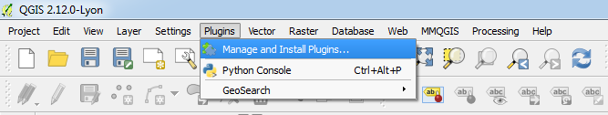

Figure 2: QGIS windows to “Manage and Install Plugins” and an example for the OpenLayers plugin.

If the installation has been successful, you should see a new menu item on Web > open layers > … with a large number of geo-spatial data sources (Figure 3). Selecting any of these sources should add a new raster layer to your QGIS Layer Panel.

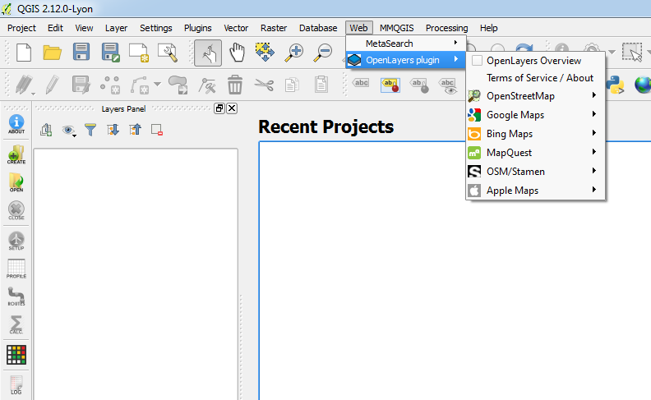

Figure 3: The “OpenLayers” plugin is accessible from the QGIS toolbar under the tab named “Web”

## Geographiclib

Geographiclib is used for performing geographic transformations and for solving geodesic problems. For more information the reader is referred to the official site: <http://geographiclib.sourceforge.net/>.

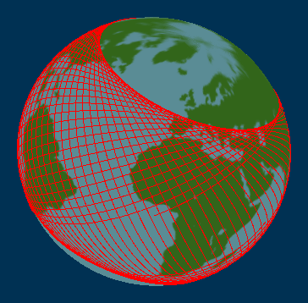An **automatic installation of geographiclib** on the first start of QGIS with Open-ALAQS was added to facilitate the installation for first-time users. In order to properly install geographiclib, the user should start QGIS as "administrator". This can be done by right clicking on the executable file and selecting "Run as administrator".

To manually install *geographiclib*:

1. Copy file “INSTALL_geographiclib.py” from the Open-Alaqs folder to **C:\INSTALL_geographiclib.py**
2. Start QGIS as administrator
3. Open a new python console inside QGIS (plugins > python console) and type:

**import os; os.system("C:\\INSTALL_geographiclib.py");**

Check if installation was successful by typing to the python console:

**import geographiclib**

The Installation was successful if no error appears. The file C:\INSTALL_geographiclib.py can now be deleted.

The library is licensed under the MIT/X11 License; this license applies to GeographicLib, versions 1.12 and later.

## Spatialite 64-bit

SpatiaLite is an open source library used in Open-ALAQS to extend the SQLite core to support fully-fledged Spatial SQL capabilities. SQLite with SpatiaLite can effectively deploy an alternative open source Spatial DBMS roughly equivalent to PostgreSQL + PostGIS.

The newest 64-bit version of Spatialite binaries (for Windows) was released on 01/07/2015. It is available from the following address: <http://www.gaia-gis.it/gaia-sins/windows-bin-amd64/>

A list of all the compressed files that are needed as well as their contents is given below.

* **mod_spatialite-4.3.0a-win-amd64.7z**
* libfreexl-1.dll
* libgcc_s_seh_64-1.dll
* libgeos_c-1.dll
* libgeos-3-5-0.dll
* libiconv-2.dll
* liblzma-5.dll
* libproj-9.dll
* libsqlite3-0.dll
* libstdc++_64-6.dll
* libxml2-2.dll
* mod_spatialite.dll
* sqlite3.exe
* zlib1.dll
* **spatialite-4.3.0a-win-amd64.7z**
* spatialite.exe

SpatiaLite is licensed under the MPL tri-license terms; the user is free to choose the best-fit license between, MPL 1.1, GPL v2.0 (or any subsequent version) or LGPL v2.1 (or any subsequent version).

## Open-ALAQS

Open-ALAQS is distributed as a zip file which, when extracted, contains a single folder called Open-ALAQS. This file contains an entire plugin for QGIS and appends the QGIS system with all the functions needed to build, run, and analyse an Airport Local Air Quality Study. To make this plugin visible to QGIS, you must copy it to the plugin’s directory.

Assuming you kept the default installation options for QGIS, there are two directories into which you could deploy the project:

* For most 3rd party plugins, the Open-ALAQS directory should be copied to:

C:\Users\YOUR_USER_NAME\.qgis\python\plugins

* If this path is not available (please contact support before using this solution), then there is a second plugin directory (intended for QGIS core plugins) which can be found at:

{YOUR_QGIS_PATH}\apps\qgis\python\plugins

Having copied the plugin into the appropriate directory, restart QGIS. Following the same procedure as described above for “OpenLayers” will bring up a dialog window that displays all of the plugins currently available locally for QGIS. Filter and activate the Open-ALAQS plugin.

## AUSTAL2000

AUSTAL2000 is the official reference model of the German Regulation on Air Quality Control (Technische Anleitung zur Reinhaltung der Luft, TA Luft) and implements the specifications and requirements given therein, in particular in Appendix 3 of the regulation.

AUSTAL2000 is constantly maintained by the German Federal Agency. The German Federal Agency agreed to allow EUROCONTROL to include 3-dimensional emission grids into the official model AUSTAL2000 version (preliminary version 2.7).

Executables (32-bit) are provided for Windows and Linux, including the complete source code (web site www.austal2000.de, German/English). The programs have been developed and tested under Windows (XP/Vista/7) and Linux (SUSE and Ubuntu). Full documentation (including installation instructions) in English is provided in the following address: <http://www.austal2000.de/data/2014-09-03/austal2000_en.pdf>

Finally, we note that AUSTAL2000 is provided free of charge under the GNU Public Licence.

# Create a new study

In this section, the main steps that are necessary to start an Open-ALAQS study are explained: **import a map** and **setup a new study**.

## Import a map

Before any emission data can be generated from the Open-ALAQS tool, it is necessary to load the background mapping data. If no mapping data (for example GIS or CAD) are provided for the airport of interest, one of the Open Layers needs to be used. This can be achieved from the QGIS toolbar (as shown in Figure 4).

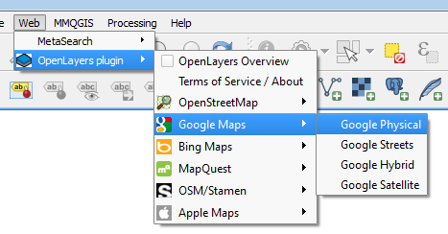

Figure 4: Choose a background map from OpenLayers plugin

Web > OpenLayers plugin > Google Maps > Google physical

## Setup a new study

The next step is to create a new project. From the Open-ALAQS toolbar (seeFigure 5) click on the “*Create”* icon. A pop-up window opens (“*Create new ALAQS database*”), allowing you to name the project (“*File Name*”) and define the directory (“*File Directory*”) where the project will be saved (Figure 6). Then, click on the “*Create Project* *Database*” to begin your new study.



Figure 5: The Open-ALAQS toolbar

If you wish to open a previously created project, click on the *Open* button (Figure 7). A window opens, allowing you to choose the location of the project.

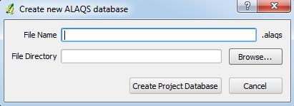

Figure 6: Open-ALAQS window for creating a new ALAQS database

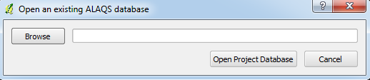

Figure 7: Open-ALAQS window for opening an existing ALAQS database

After the creation or opening of a project, the “*ALAQS Study Setup*” window (Figure 8) opens automatically. Alternatively, the user can access it by clicking on the *Setup* button of the Open-ALAQS toolbar.

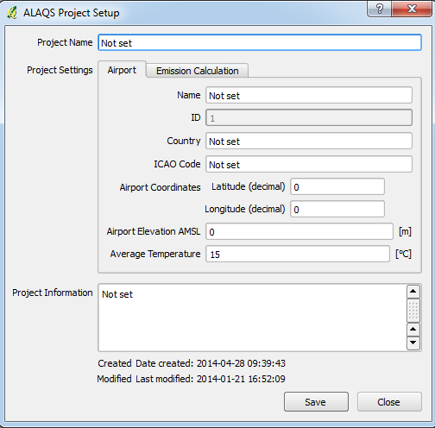

Figure 8: Open-ALAQS Study Setup window

In this window, it is possible to define several parameters such as the:

* Project name
* Airport name
* Airport ICAO code
* Airport country
* Airport coordinates: latitude, longitude and elevation AMSL (above mean sea level, in meters)
* Average temperature (in degrees Celsius)
* Vertical limit (in meters): *default value is 913 m.*
* Parking method
* Roadway method: ALAQS method
* Roadway fleet year (values: from 1990 to 2020 in steps of 5)
* Roadway country (values: FR, UK, etc.)
* Study information (optional)

## Define emission sources

The emission sources currently available in Open-ALAQS (Figure 9) can be grouped in two main categories: *Aircraft related* and *Stationary* (non-aircraft) sources. These sources are represented either as *points*, *lines* (single or multi-segment) or *areas* (polygons).

The emission sources types included in Open-ALAQS are:

* 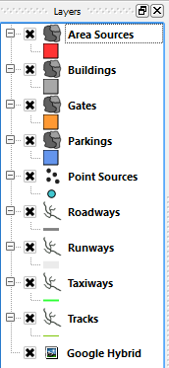Area sources (polygons)
* Buildings (polygons)
* Gates (polygons)
* Parking lots (polygons)
* Point sources (point)
* Roadways (line)
* Runways (line)
* Taxiways (line)
* Tracks (line)

Figure 9: Open-ALAQS emission sources as found in the Layers toolbar.

Before taking a detailed look into these different types of emission sources, the *Add*, *Edit* and *Visualise / Edit Attribute* options for the above layers (emissions sources) are presented:

#### Add Features

New objects can be added using the *Digitizing* toolbar (Figure 10). First, click on *Toggle Editing* to go to editing mode and then click on the *Add Feature* button.



Figure 10: The QGIS Digitizing toolbar. The Toggle Editing button is highlighted.

When creating a new utility, a pop-up window appears allowing you to define the utility's characteristics or attributes. For each field, tooltips provide information on the accepted data type (string/integer/float). When all the required fields have not been filled in, an information dialog appears and the mandatory fields not filled in correctly appear in red in the form.

#### Edit Features

Using the *Digitizing* toolbar in the editing mode (*Toggle Editing*), it is possible to employ *Move Feature* and *Node Tool* buttons to move objects and edit their nodes. *Save Edits* will save any changes made to the specific layer.

#### Delete Features

To delete features, select them first using the *Attributes* toolbar (*Select Single Feature*), activate editing mode with editing with *Toggle Editing* and then click on *Delete Selected* in the *Digitizing* toolbar.

#### Visualize and Edit Attribute Values

The attribute values can also be modified after the object's creation via the *Attribute Table*. The Open Attribute Table functionality can be accessed via the *Layers* panel (by right-clicking on the appropriate layer) or through the *Attributes* toolbar (Figure 11). The attributes and attribute values of a given feature can be visualised using the *Identify features* tool in the *Attributes* toolbar.



Figure 11: The QGIS Attribute panel

Next, we present the characteristics of different layers that can be defined in Open-ALAQS. These features can be grouped in two categories (*Aircraft related* and *Other)* and arepresented below. The procedure for adding a source is always the same. First, the user defines the desired source geographically and then fills the necessary information fields before registering (saving) the source. For every one of the following sources there are two common properties that must to be provided by the user: “*Name”* (the source identification name) and whether the specific source will be taken into account for the calculation of the emissions (“*In Study”* option).

#### Activity Profiles

Activity Profiles are used to describe the relative hourly/daily/monthly activities for each airport emission source. Each activity multiplier (hourly/daily/monthly values) is a decimal number, which usually is within the interval [0.0, 1.0]. The default profile values are 1 (i.e. 100%). The profile feature in the Open-ALAQS toolbar can be used to review, edit and create custom profiles. As an example, these custom profiles may include increased activity during working days, but decreased activity during weekends or nights. The *Activity Profiles* editor is shown in Figure 12.

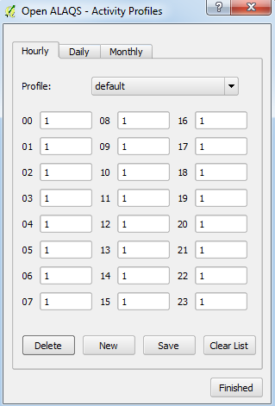

Figure 12: Open-ALAQS Profiles editor. The user can edit the default activity profile or create a new hourly/daily/monthly profile.

### Aircraft related Sources

For aircraft emissions four feature layers need to be captured: runways, taxiways, gates and tracks. For each of these features the user has to enter the required attributes.

#### Gates

A gate is the arrival or departure place of aircrafts. The methodology used in Open-ALAQS for calculating gate emissions requires establishing the sum of three types of emissions: GSE (Ground Support Equipment), APU (Auxiliary Power Unit), GPU (Ground Power Unit) and MES (Main Engine Start). In Open-ALAQS, gates are represented as polygons.

When adding a gate, the following (mandatory) information is required:

* Gate type (*PIER*, *REMOTE* or *CARGO*)
* Gate height

Open-ALAQS includes a functionality to assign an emission factor (expressed in terms of grams of pollutant per aircraft handled at the gate) related to the activities of Ground Support Equipment as a function of:

* The type of gate (pier, remote, general aviation, cargo, etc.).
* The category of handled aircraft (jet business / regional, jet small, jet medium, turboprops, piston).
* The description of the types of GSE available at the airport (in terms of technology and power) and the activity time (per aircraft category), which are provided by default with the plugin.

#### Runways

Runways are linear features defining the vertical plane in which approach, landing, take-off and climb out operations take place. Based on the direction of the movement along this line, each end is treated as a specific runway.

When adding a taxiway, the following (mandatory) information is required:

* Capacity (departures/hour)
* Touchdown offset (meters)
* Maximum queue speed (km/h)
* Peak queue time (minutes)

#### Taxiways

A taxiway is a physical band of concrete on which aircrafts taxi. The length of each taxiway is calculated internally. The aircraft-main engine emissions on each taxiway segment are calculated using the ICAO Engine Emissions Databank (Idle “ID” mode).

When adding a taxiway, the following information is mandatory:

* Speed (km/h)

Recommended taxiing speeds vary in relation to ambient conditions, traffic, aircraft position on the taxi route etc. Typical taxiing speeds lie between 10 and 40 km/h (~5 and ~25 kts).

#### Tracks

When adding aircraft tracks, the following information is mandatory:

* Related runway from the list of previously defined runways.
* Whether the track is designed for arrival or departure operations.

### Stationary (Non-Aircraft) Sources

For non-aircraft emissions four additional stationary can be accounted for: **area sources, roadways and parking lots**. For each feature captured the user has to enter the required attributes.

#### Area Sources

This emission source includes emissions from sources other than parking lots and gates (e.g. de-icing/anti-icing, fuel storage units, etc.). The emission for any area source for each time period is equal to the total emission for the entire time period multiplied by the activity factor for the specific hour.

When adding an area source, the following (mandatory) information is required:

* Parameters:
* Units: Number of units consumed per year
* Height: Height at which emissions are released (in meters)
* Heat Flux: Heat flux (in Megawatts)
* Emissions: Emission factors for CO, HC, NOX, SOX, PM10 (in kg/unit)
* Profiles: Hourly, Daily or Monthly activity profiles

#### Buildings

Buildings are not considered as emission sources. However, buildings are significant for future dispersion modelling (blocking wind and turbulence fields).

When adding a building, the following detail is required:

* Building height (Height of building above ground, in meters)

#### Parking Lots

Emissions from parking areas for vehicles inside an airport’s boundaries are account for in Open-ALAQS using the EUROCONTROL ALAQS method (based on COPERT-IV). The emission for any parking lot for each time period is equal to the length of the parking in km multiplied by the average emission per vehicle per km multiplied by the number of vehicles for the time period multiplied by the activity factor for the specific hour. When adding an airport parking space (for vehicles), the following (mandatory) information is required:

* Parameters:
* Number per year: Total number of vehicles per year
* Height: Height at which emissions are released (in meters)
* Speed: Average travel speed in parking (in km/h)
* Travel distance: Average travel distance in parking (in meters)
* Idle time: Vehicle average idling time between entry and exit (in minutes)
* Average parking time: Average time a vehicle remains on parking (in minutes)
* Profiles: Hourly, Daily or Monthly activity profiles
* Emissions: Emission factors for CO, HC, NOX, SOX, PM10 (in grams/vehicle)
* Fleet mix (in %): PC (Passenger Cars), LDV (Light Duty Vehicles) or HDV (Heavy Duty Vehicles)

#### Point sources

Stationary or infrastructure-related emissions from airport facilities such as power and heating plants, incinerators, training fires, fuel storage tanks are accounted for and are represented as point sources in Open-ALAQS. The emission for any point source for each time period is equal to the total emission for the entire time period multiplied by the activity factor for the specific hour. When adding a point, the following (mandatory) information is required:

* Parameters:
  + - Category: Source category (Tank, Incinerator, Other, Power/Heat plant, Solvent degreaser, Surface coating)
    - Type: Category specific type (Oil or diesel, Automobile gasoline, Aviation gasoline, JP4, JP5, JET A)
    - Substance: State of fuel (Solid, Liquid or Gas)
    - Height: Height at which emissions are released (in meters)
    - Units per year: Volume or mass units
    - Temperature: (in degrees Celsius)
    - Diameter: (in meters)
    - Gas Velocity: (in meters per second)
* Profiles: Hourly, Daily or Monthly activity profiles
* Emissions: Emission factors for CO, HC, NOX, SOX, PM10 (in kg/k)

#### Roadways

Emissions from an airport’s internal roadway traffic are accounted for by using “*Roadways”*. The vehicles emissions for a specific roadway are equal to the length of the roadway in km multiplied by the average emission per vehicle per km multiplied by the number of vehicles for the time period multiplied by the activity factor for the specific hour.

When adding a vehicles roadway, the following (mandatory) information is required:

* Parameters:
* Movements: Number of movements per year
* Height: Height at which emissions are released (in meters)
* Profiles: Hourly, Daily or Monthly activity profiles
* Emissions: Emission factors for CO, HC, NOX, SOX, PM10 (in g/km)
  + Speed: Vehicles speed in roadway (in km/h)
  + Scenario: *Not applicable in this version of Open-ALAQS*
  + Fleet mix: PC (Passenger Cars), LDV (Light Duty Vehicles), HDV (Heavy Duty Vehicles)

# Emissions inventory

In order to generate an emission inventory in Open-ALAQS the user needs to provide a *Movement Table* and define the trajectory of the movement (*Gate, Taxiing Route, Runway*).

## Aircraft movements

#### Movement Table

A movement table lists the aircraft movements occurring at the airport during a certain period. The movement table can be imported by clicking on the *Calculate Emissions Inventory* button (in the Open-ALAQS toolbar) and then *Browse Movement Table*. The input data can be in either CSV or TXT format.

An Open-ALAQS movement table contains the following information:

1. **Date and time of movement**: “*date_time”* (in a dd/mm/YYYY HH:MM:SS format)
2. **On-block/off-block time and date**: “*block_time” (*in a dd/mm/YYYY HH:MM:SS format)
3. **Aircraft registration**: “*ac_reg”* (given as a string)
4. **Aircraft type** (ICAO type): “*aircraft”* (given as a string)
5. **Gate identifier**: “*gate*” (given as a string)
6. **Type of movement** (unless *block_time* is known): “*dep_arr*” (A for arrival, D for departure)
7. **Runway identifier**: “*runway*” (given as a string)
8. **Engine identifier**: “*eng_name*” (given as a string) as per the ICAO / FOCA emission databanks
9. **Vertical profile identifier**: “*prof_id*” (given as a string)
10. **Horizontal profile identifier**: “*track_id*” (given as a string)
11. **Taxi route instance identifier**: “*taxi_route*” (Integer)
12. **Takeoff Gross Weight divided by Maximum Takeoff Weight**: “*tow_ratio*” (Float, <= 1)
13. **Code defining APU usage away from gate/stand**: “apu_code” (Integer, 0: APU used at gate only, >= 1: APU on while taxiing, >= 2: APU on during taxiing, takeoff, climb or approach)
14. **Taxiing engine count** (between 0 and engines number): “*taxi_engcount*” (Integer, 0: operational aircraft towing, 0 < *taxi_negcount* < engines number: engine-out taxiing)
15. **Taxiing fuel ratio** (actual fuel flow / fuel for the idle mode): “*taxi_fuelratio*” (Float)
16. **Domestic/international flight**: “*domestic*” (Y or N)

The *Date_time* and *block_time* parameters are used to derive the type of movement (arrival or departure) as well as the exact taxiing time for that movement for the emission inventory. Taxi-routes must be calculated for every gate and every runway exit point.

#### Routes

Routes (or taxi-routes) are defined as a series of taxiway segments that link a runway and a gate. To define a route in Open-ALAQS, the user has to manually select all the necessary taxiway segments, which correspond to a specific route for each movement type (arrival or departure). Once defined, the taxi routes are used for the emissions calculation. Open-ALAQS is allocating a route to each movement depending on its origin and destination (i.e. gate & runway for a departure, and runway & gate for an arrival). Gate emissions are computed for each movement at the time specified in the movement table.

## Meteorology

Open-ALAQS requires certain meteorological data in order to accurately calculate emissions using advanced methods (e.g. BFFM2 method, correction of NOx for ambient conditions).

The input parameters are:

1. **Date and Time** (YYYY-mm-dd hh:mm:ss)
2. **Temperature** (in K)
3. **Humidity** (in kg water/kg dry air)
4. **Relative Humidity** (in %)
5. **Sea Level Pressure** (in mb)
6. **Wind Speed** (in m/s)
7. **Wind Direction** (in degrees)
8. **Mixing Height** (in m)

In addition to these data, the dispersion model used by Open-ALAQS (AUSTAL2000) requires the **Monin-Obukhov Length**.

Input data may come from local or national data providers (e.g. METAR, SYNOP) or reanalysis data. The compilation of a meteorological input file for Open-ALAQS/AUSTAL2000 (Table 1) is left to the user.

Table 1: Example of a meteorological input file used in Open-ALAQS

|  |  |  |  |  |  |  |  |  |  |  |  |  |  |  |
| --- | --- | --- | --- | --- | --- | --- | --- | --- | --- | --- | --- | --- | --- | --- |
| Date Time | Temp. (K) | | Humidity (kg_water /kg_dry_air) | Relative Humidity (%) | | Sea Level Pressure (mb) | | Wind Speed (m/s) | | Wind Direction (degrees) | | Mixing Height (m) | | |
| 2015-03-01 00:00:00 | 276.6 | 0.00634 | | | 0.66 | | 99800 | | 2.041 | | 2.526 | | 914.4 |
| 2015-03-01 06:00:00 | 275.9 | 0.00634 | | | 0.75 | | 99800 | | 3.037 | | 355.847 | | 914.4 |
| 2015-03-01 12:00:00 | 279.9 | 0.00634 | | | 0.78 | | 99400 | | 3.206 | | 326.062 | | 914.4 |
| 2015-03-01 18:00:00 | 280 | 0.00634 | | | 0.81 | | 98100 | | 3.010 | | 353.323 | | 914.4 |
| 2015-03-02 00:00:00 | 281.2 | 0.00634 | | | 0.91 | | 98100 | | 4.131 | | 320.105 | | 914.4 |

## Generate emission inventory

When the *Movement Table* is compiled and *Routes* are defined, emissions can be calculated by clicking on the *Calculate* button of the Open-ALAQS toolbar (Figure 5). A new window (Figure 13) will appear where the user will have to specify the path to the Movement table, a name for the output file and the corresponding output path. A browse button is provided to facilitate these steps. Next, the *Study Start* and *End Date* need to be selected. The vertical limit is by default 914.4 meters and the Towing speed is predefined at 10 km/h. The user is free to decide which emission sources will be accounted for in the calculation (all sources are selected by default). The resolution of the modelled domain is set to 250 x 250 x 10 meters; however, the user can modify these values as needed.

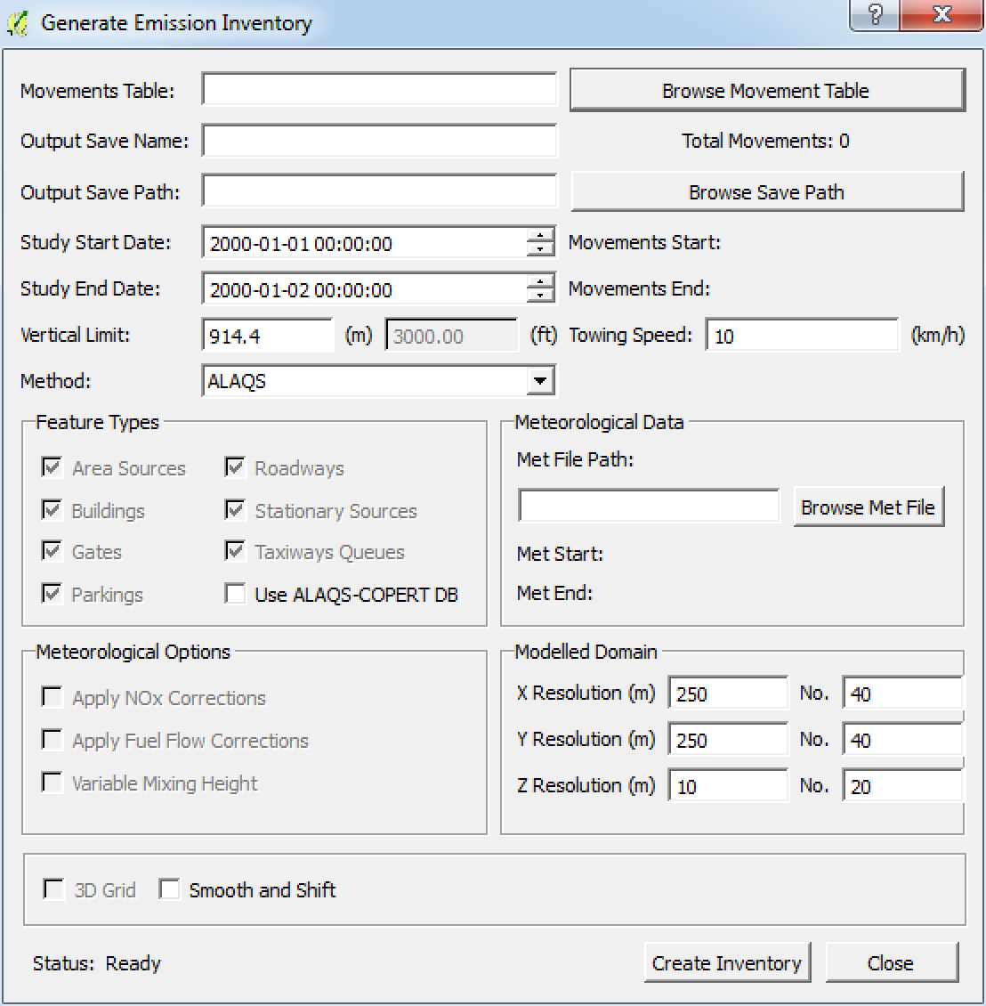

Figure 13: Generate Emission Inventory window. Before emissions can be calculated, the user has to compile a Movement Table and define the airport’s taxi routes.

The final step to generating the emissions inventory is to click on the *Create Inventory* button. A status indicator is added to the window that provides information about the operation in progress. When the calculation is finished an additional window will pop-up (Figure 14) indicating the end of the process.

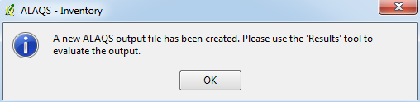

Figure 14: The Open-ALAQS Inventory completion window.

## Calculate emissions & Query results

To calculate emissions and see the results, click on the button from the Open-ALAQS toolbar. A new window will appear (Figure 15) where all source types and names (stationary or aircraft-related) can be browsed. Choose the pollutant and the name of the source (in case of multiple sources of a specific kind) to view the corresponding emissions.

There is two different ways to query the calculated emissions: i) view results in a table format (“Results table”) and ii) export results in a .csv (“Export to CSV”) or SQL (“Export to DB”) file. This can be achieved from the “Output Modules” tab. Moreover, the “Emissions Calculation” tab can be used to choose the preferred calculation method, define the time interval and the vertical limit (height).

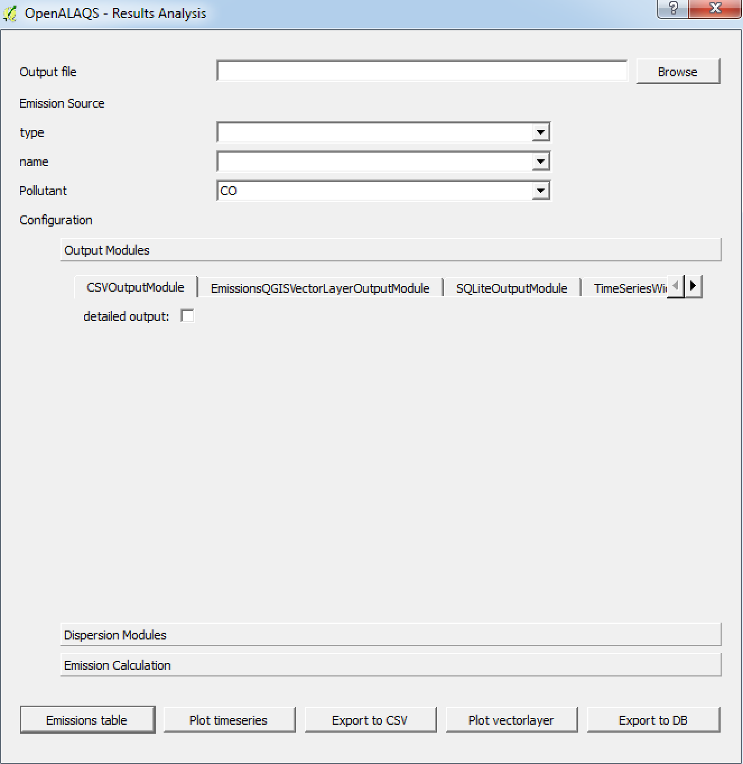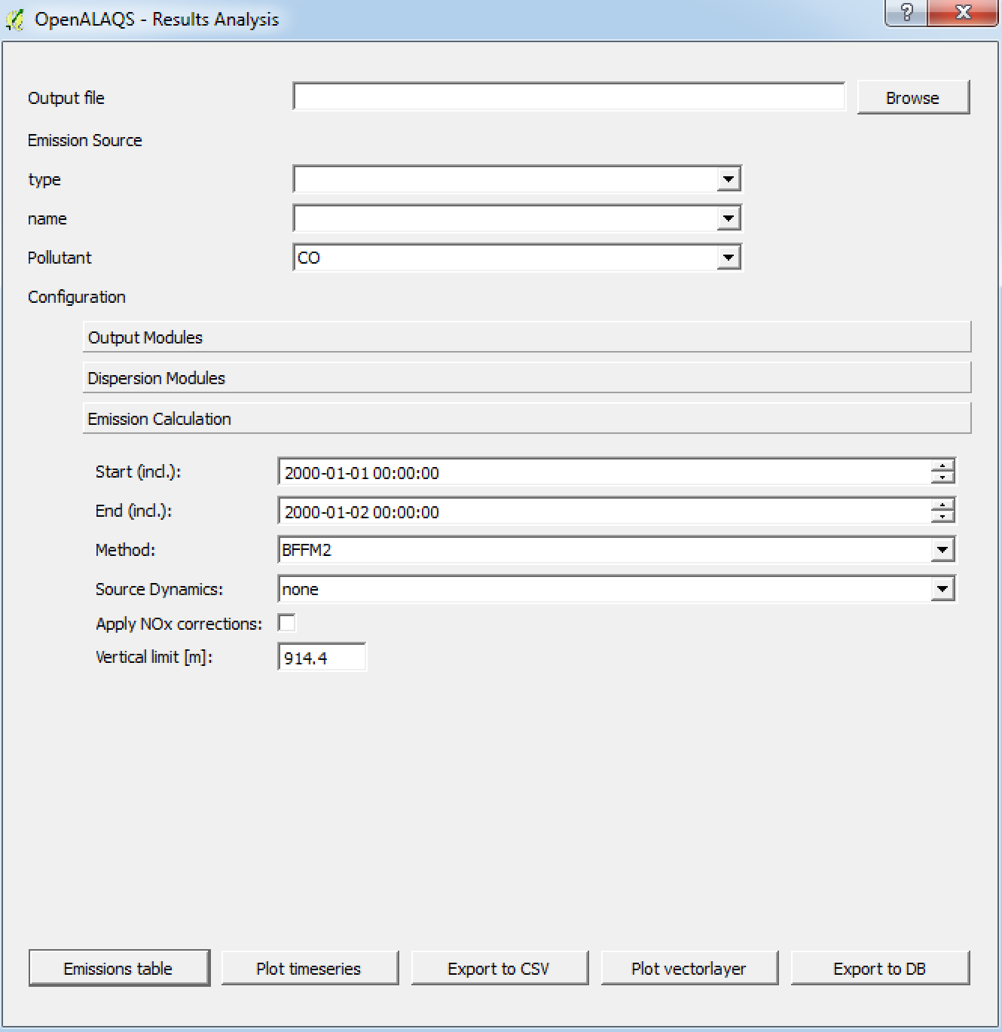

Figure 15: The Open-ALAQS “Query Results” window.

#### Calculation of aircraft emissions

Two methods for the calculation of aircraft emissions have been implemented in Open-ALAQS: “by mode” (i.e. adjusted times-in-mode with default fuel flow and emissions indices) and the advanced method Boeing Fuel Flow Method 2 (or BFFM2), which was implemented following the recommendations of the ICAO Doc 9889 Airport Air Quality Manual.

The emissions of particulate matter PM10 were based on emission indices derived from the smoke number of the ICAO databank following the First Order Approximation v3.0 (FOA 3.0).

The correction of NOX emission indices for ambient conditions has also been implemented in Open-ALAQS following the recommendations of ICCAIA. This method can be applied only for the “by mode” method.

As regards fuel flow and emission indices of aircraft engines the ICAO engine exhaust emissions databank (Issue 22) is used for turbofan engines’ aircraft, combined with the FOCA databank for pistons. The confidential FOI databank for turboprops can also be added if the user has permission to use it. We note that ICAO does not have emissions certification standards for SOX. Emissions of SOX have been implemented according to the U.S. EPA recommendation for commercial aviation jet fuel: EI SOX = 1 g/kg of fuel. This average value should not be relied upon where validated data are needed, but can be used to perform an emissions inventory of SOX emissions when more precise data are not available.

Finally, the possibility to account for source dynamics has been added to the “Emissions Calculation” tab. This is achieved by using the “Smooth & Shift” approach. This method has already been used to connect the emission grid provided by the precursor model of Open-ALAQS, ALAQS-AV, to dispersion models. The methodology is described in the report EEC/SEE/2005/016 by EUROCONTROL.

## Visualize results

Emissions can be also viewed as a time-series plot or as grid cells on a map from the same window (Figure 15). This can be achieved from the “Output Modules” tab as described in the previous section. A time-series plot shows the temporal variability of an emission type/source or pollutant on a x-y axis graph. The EmissionsQGISVectorLayerOutputModule is used to superimpose the calculated emissions on the mapping layer using a predefined grid (see Figure 13). In order to minimize the computation time a threshold value per grid cell can be defined. Again, the “Emissions Calculation” tab can be used to choose the preferred calculation method, define the time interval and the vertical limit (height).

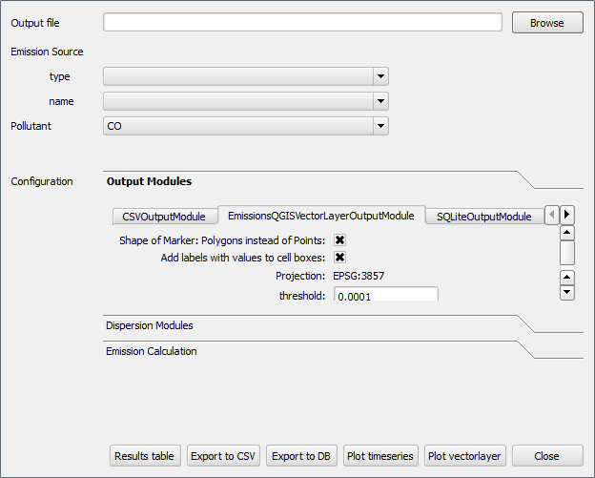

Figure 16: The Open-ALAQS Visualization window

## Dispersion with Open-ALAQS/AUSTAL2000

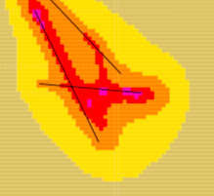The connection of Open-ALAQS with AUSTAL2000 was realized based on the existing architecture of Open-ALAQS code. In order to retain the flexibility of Open-ALAQS, two new modules were developed: one for producing the input files for the dispersion model and a second for launching AUSTAL2000 and exploring the calculated concentrations. As a result, Open-ALAQS remains independent of the dispersion model and other similar modules can be added in the future.

The first module (named AUSTAL2000) was incorporated to the existing “Results analysis” window; under the “Dispersion Modules” tab. Figure 17 shows the new module as well as the parameters that are necessary for an AUSTAL2000 simulation. These are:

* "**enable**"
* “**add title**"
* "**roughness length (in m)**":
* "**anemometer height (in m)**"
* "**displacement height (in m)**”
* "**options string**”
* "**quality level**"
* "**index sequence**"

The user is referred to the AUSTAL2000 documentation for a detailed description of the above parameters.

The AUSTAL2000 module will be run only if “enable” is checked. By default, the checkbox is unchecked. Once enabled, the user will have to select any of the other output modules (e.g. “*Emissions table*”, “*Plot timeseries*”, etc). This procedure allows gaining time as the emissions will be calculated first (with the chosen output module). The user can then explore the calculated emissions or proceed to a simulation with AUSTAL2000.

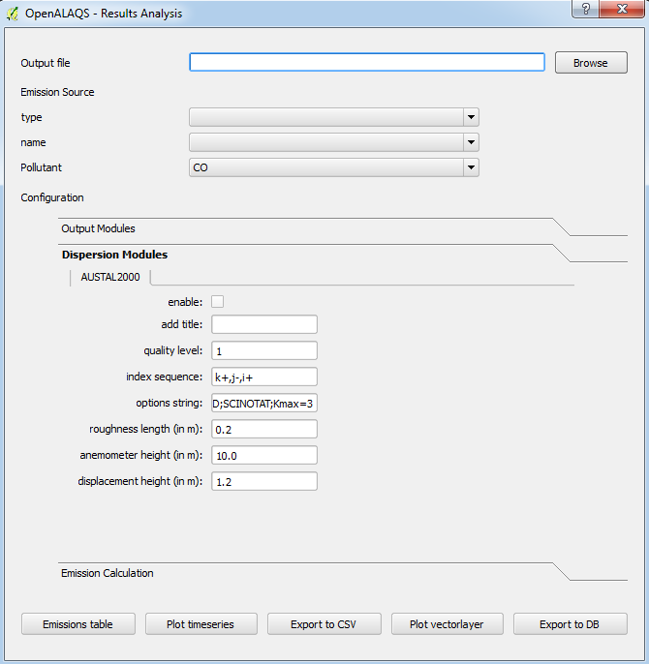

Figure 17: The new Open-ALAQS "Results Analysis" window featuring the AUSTAL2000 output module.

The second module (named “Calculate Dispersion”) was added to the Open-ALAQS toolbar. The new module allows performing independent dispersion simulations (no need to run Open-ALAQS every time) and/or exploring the output of an AUSTAL2000 simulation.

For a simulation with AUSTAL2000, the user will have to specify the path to the austal2000 executable as well as the path to the work directory where all output files will be written. By default, a file named austal2000.txt is written at the end of the calculation. If the user activates Option –D, the austal2000.txt file is overwritten.

To explore the results of a simulation, the user has to select the Open-ALAQS file used for the calculation (in order to use the exact grid and date) and then click on one of the output modules. When clicked a new window will appear where the user can browse the AUSTAL2000 output files and select the one to explore (e.g. visualize the concentration on a grid).

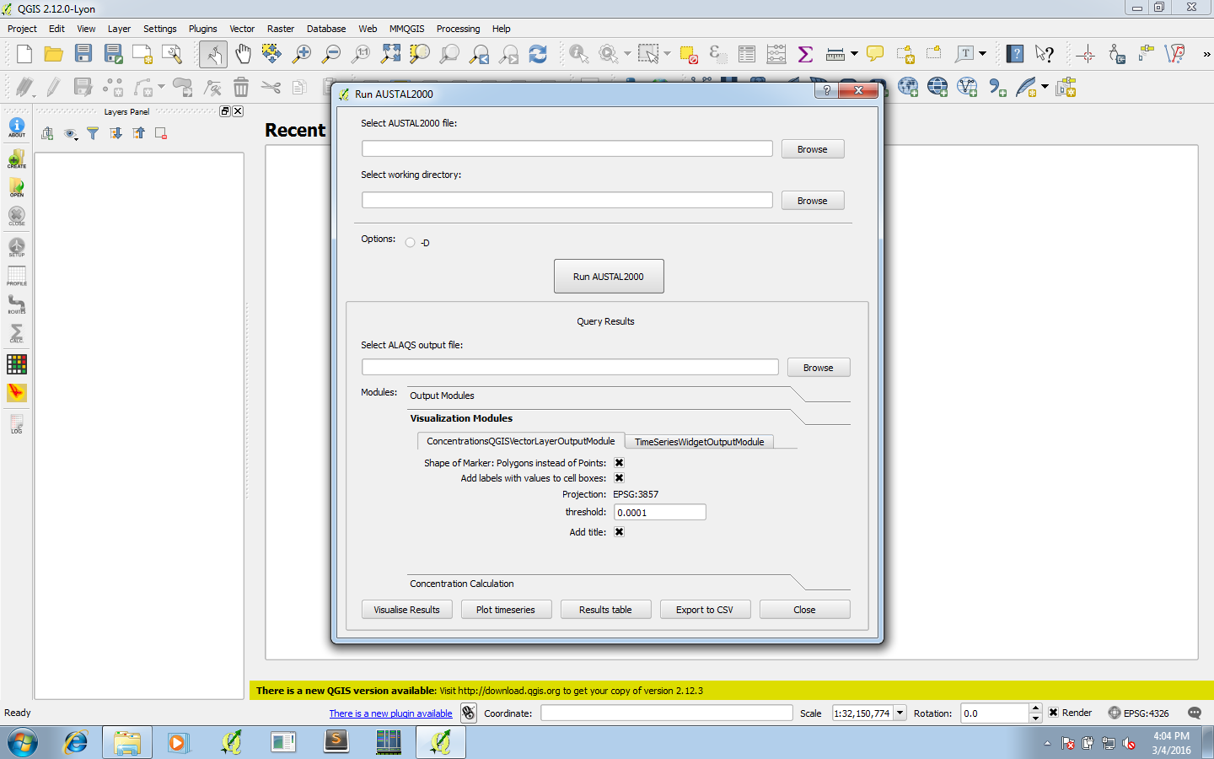

Figure 18: The new "Run AUSTAL2000" window. It can be used to run a simulation but also visualise the results.

AUSTAL2000 substance-specific output results are compatible with European legislative requirements for 8-hour, 24-hour, and annual mean values of pollutant concentrations. By default, the concentration is given for the ground layer. However, more vertical layers can be examined if necessary. Moreover, the statistical uncertainty of every concentration value is provided.

Additionally, results can be examined from within Open-ALAQS in different forms (e.g. maps, time-series, table, .csv file) and for various averaging periods according to European EC Directive 2008/50/EC. Results can be presented as annual mean, daily mean, 8h mean, or hourly values. The maximum concentration value of the user-defined grid is also available for the same time-intervals. It is also possible to visualize the moving average for daily or hourly concentration values.

# Test case study: CAEPport

In this section a test case study is presented. The purpose of this training exercise is to guide the first-time user throughout the main steps of a case study with Open-ALAQS. This test case is based on theoretical data only. All the necessary input files are provided in the *example* directory of the Open-ALAQS plugin.

The selected airport is CAEPport, a generic “mock” airport that was designed to test the candidate local air quality models that will be used in CAEP regarding basic functionality: (1) emission source characterization and (2) pollutant dispersion modelling according to a common set of input parameters, a shared set of meteorological data, and a uniform array of downwind receptors.

The CAEPport airport is fictitious and does not represent any specific airport. The location of the airport is assumed to be at 49°55'00.0"N/6°19'00.0"W, GMT time zone, with an elevation of 300 m AMSL (above mean sea level). The assumed airport operating time is 0400-2400 LT. The emissions sources considered are: Aircraft main engines (LTO cycle and start-up), Auxiliary power units (APU), Ground support equipment (GSE), Landside surface transportation equipment and parking facilities, Stationary sources, Fuel storage and handling activities, Training fires as shown in Figure 22.

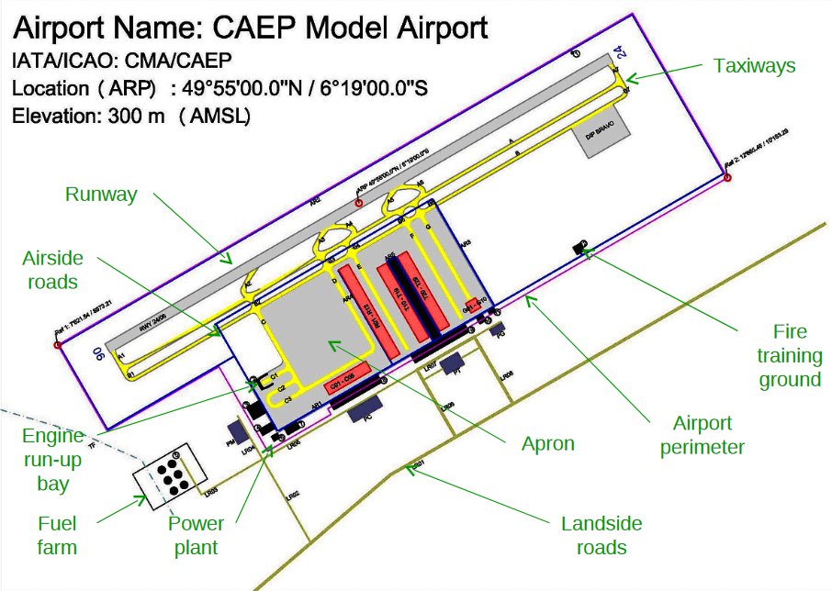

Figure 19: CAEP Airport model

Since the assumed airport is fictional it is not possible to automatically import the necessary information (e.g. Airport Name, Country, Latitude, Longitude and Elevation) from its ICAO code. However, the CAEPport image can be geo-referenced in QGIS and presented on top of a QGIS map (taken from the *OpenLayers* plugin) as shown in Figure 23. For any other real airport, the AIP can be also used instead of an image.

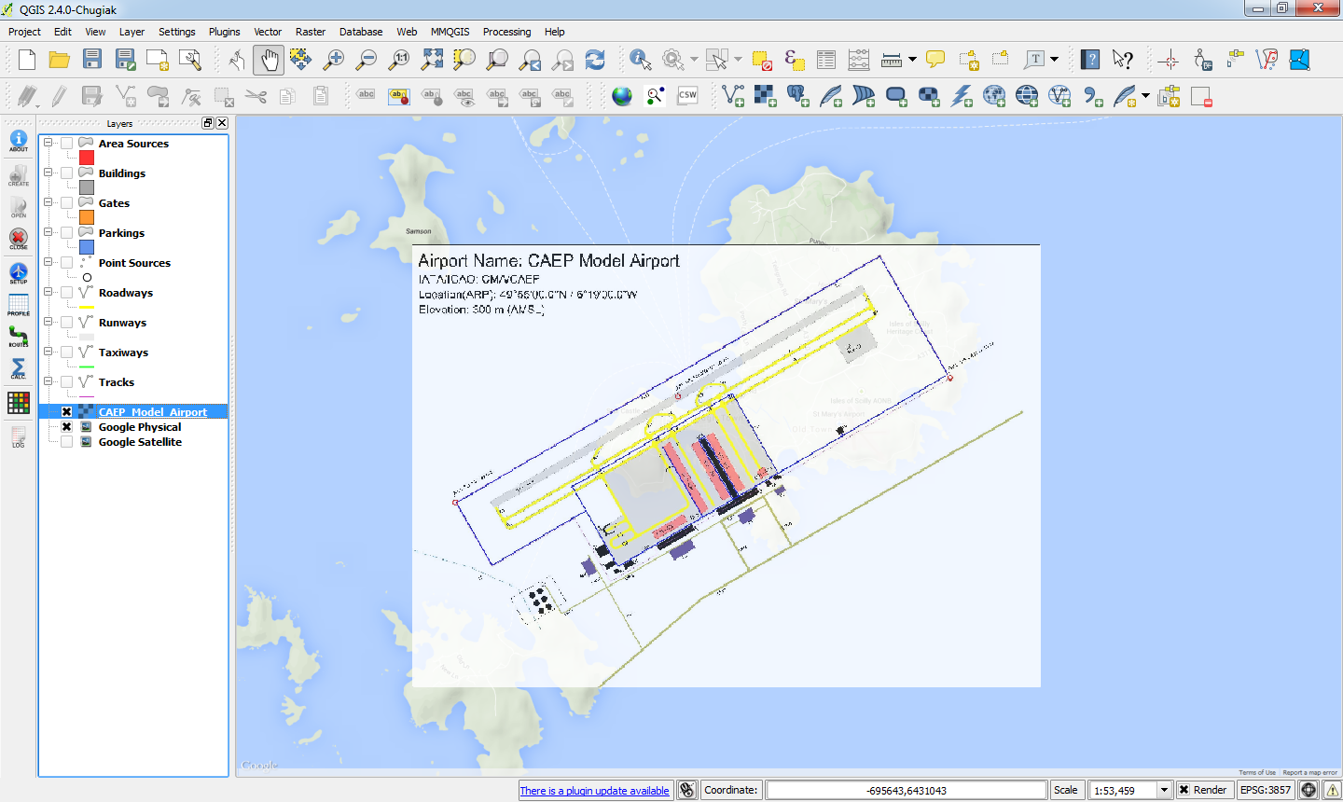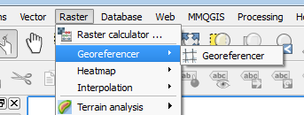

Figure 20: Geo-referencing of the CAEP model airport from the image file. The CAEP airport us superposed on a Google Map layer in QGIS and all the considered emission sources are also visible.

## Create a new study

A new study can be created by clicking on the *Create* icon from the Open-ALAQS toolbar. Choose a *File Name* and an output *Director*y (Figure 21). After clicking on the “Create Project Database” button, the “ALAQS Study Setup” dialog will appear (Figure 22).

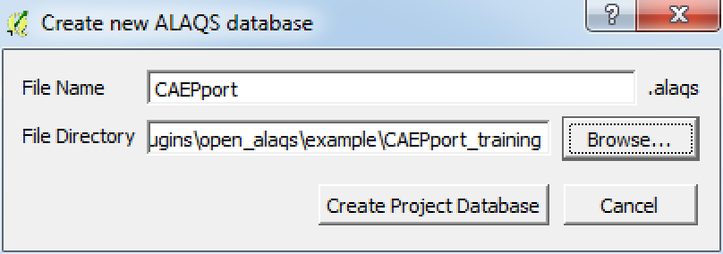

Figure 21: Create a new study Open-ALAQS window

In case of a real airport, the ICAO code can be used to automatically obtain all necessary information including the airport’s name, country, latitude, longitude and elevation. Since, CAEPport is a fictional airport these fields need to be filled manually as in Figure 22.

Next, click on the Emission Calculation tab to specify the Project Name, the Roadway Method (only ALAQS method is available in this Open-ALAQS version), the Roadway Fleet Year and Country. For this example, we choose the name “**CAEPport**”, the year **2015** and **EU** country code respectively. The average temperature (*Average Temperature*) and vertical limit (*Vertical Limit*) boxes should be pre-defined.

The last step is to save the project setup. An “*Update successful*" pop-up window confirms that the new study has being created.

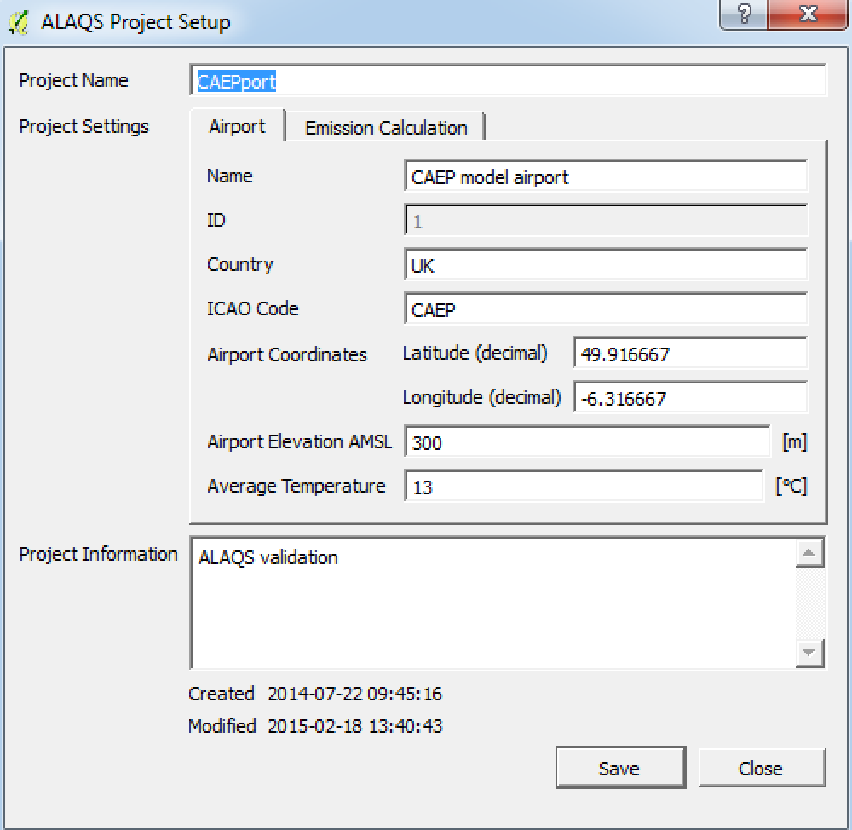

Figure 22: The Open-ALAQS Study Setup window contains information about a project.

Once the user successfully completes the study setup, several new layers appear in the Layers panel (Figure 23). The next step is to load the background map. Use Web > OpenLayers plugin > Google Satellite Layer from the QGIS menu to add a Google (or any other) Layer. As explained before, once added, the user should move the new layer below all the other layers (Figure 23).

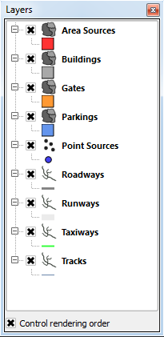 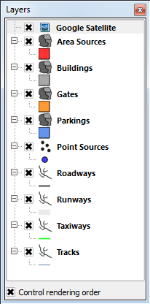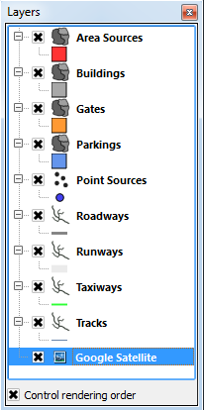

Figure 23: “*Open-ALAQS Layers” in the Layers panel*. On the right, the mapping data layer (Google Satellite) is moved below every other layer.

The Google map as well as the Open-ALAQS layers toolbar are visible inFigure 24. Next, we import the georeferenced image. To do this, go to the QGIS menu and click on ***Layer > Add Layer > Add Raster******Layer*** and select the ***CAEP_Model_Airport.tiff*** file which can be found in the *example* directory of the Open-ALAQS plugin. Figure 25 shows the georeferenced image superposed on the map.

The next step is to add one by one all the main emissions sources. We will start from Aircraft related sources (Runways, Taxiways and Gates) then move to non-Aircraft sources (Area sources, Buildings, Parking lots and Point sources).

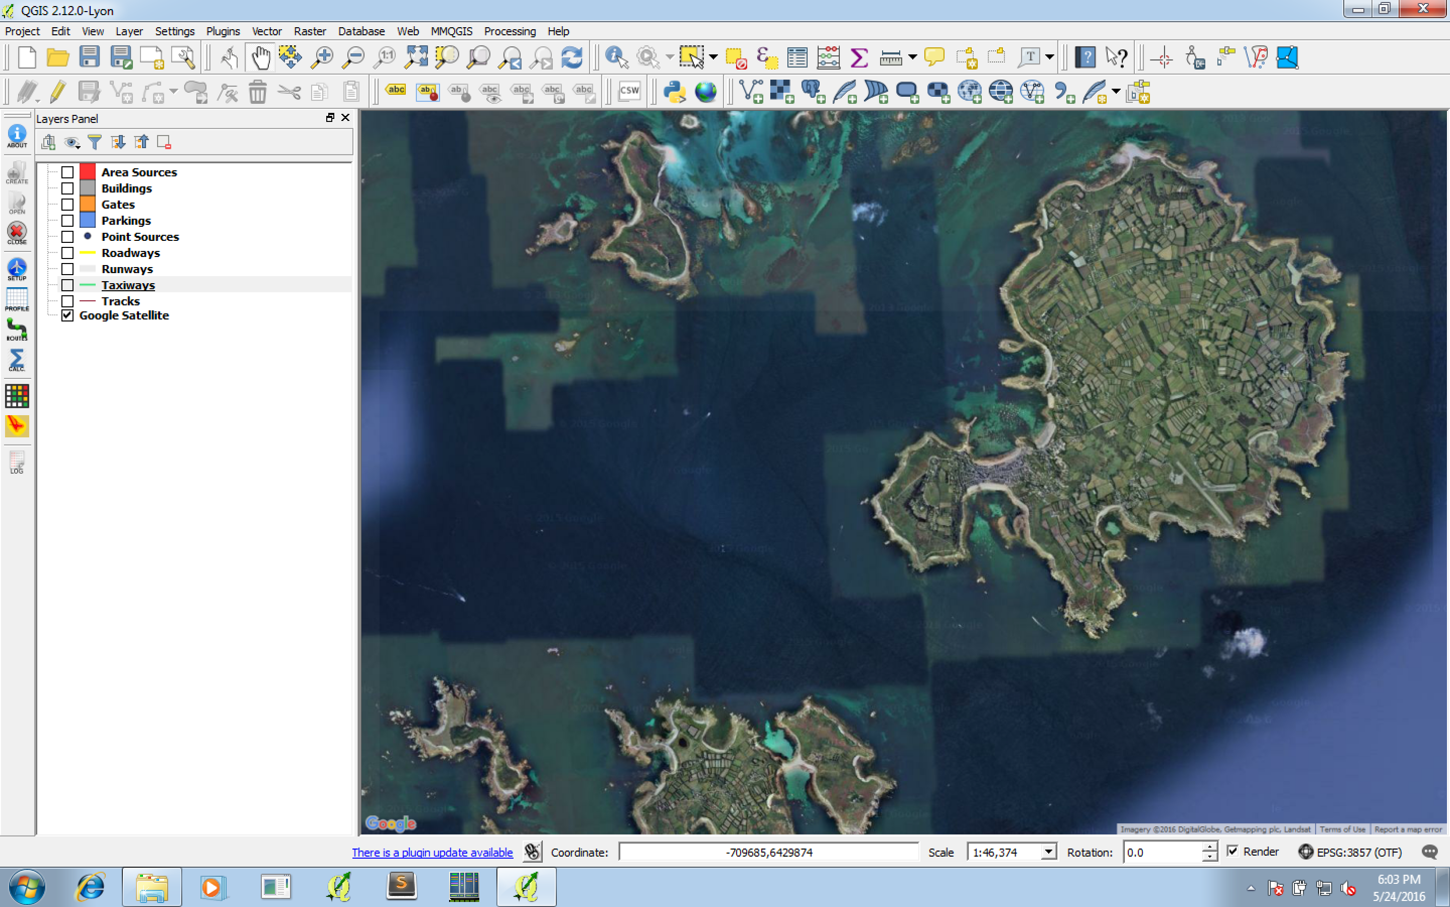

Figure 24: The Google map imported in QGIS for the CAEPport airport.

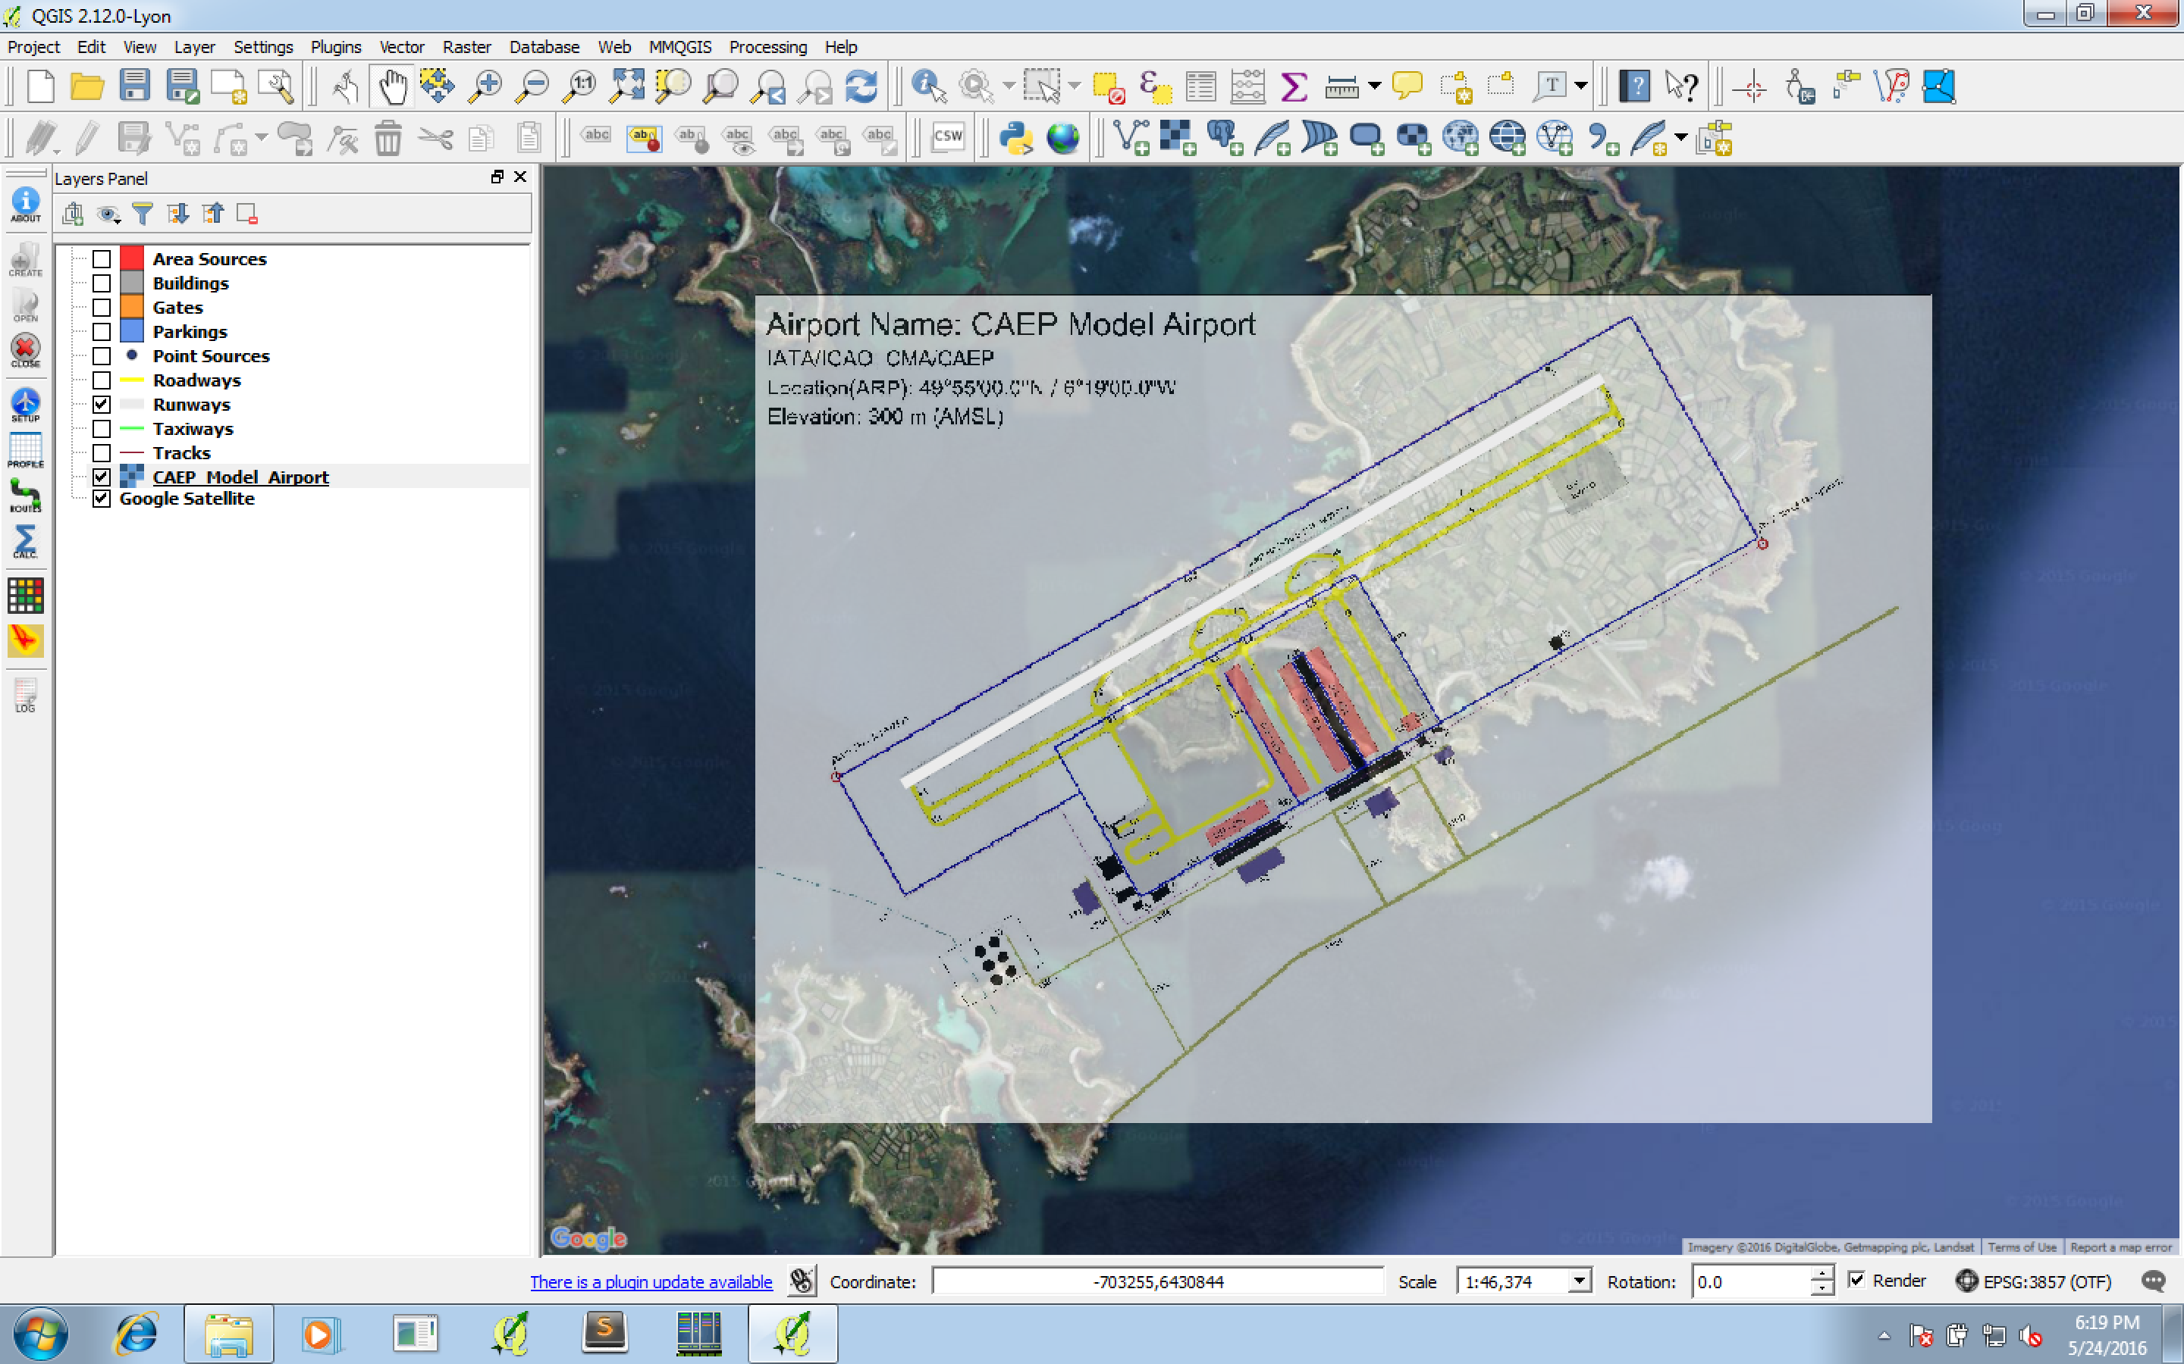

Figure 25: The georeferenced image of CAEPport superposed on a Google map Layer.

The next step is to add one by one all the main emissions sources. We will start from Aircraft related sources (Runways, Taxiways and Gates) then move to non-Aircraft sources (Area sources, Buildings, Parking lots and Point sources).

## Add aircraft-related sources

#### Add Runways

The first step is to add the airport runways. The CAEPport airport has one runway: 06/24. To design the runway, select the ***Runways*** layer from the Open-ALAQS Layers panel and click on ***Toggle Editing*** and then ***Add Feature*** from the Digitizing toolbar (*see section “Define emission sources” for more details*). Click on the starting point of the first runway and drag the pointer towards its ending point, then right-click to finalise the construction. A window will appear where all the necessary information for this source will have to be filled. For this example, enter 06 for the if the construction started from the left side (for more information on naming runways, see section “Useful Information”).

Make sure the *In Study* option is selected (to include this source in the emissions calculation) and then click OK. Remember to save the current layer before continuing. The result should be similar to Figure 26.

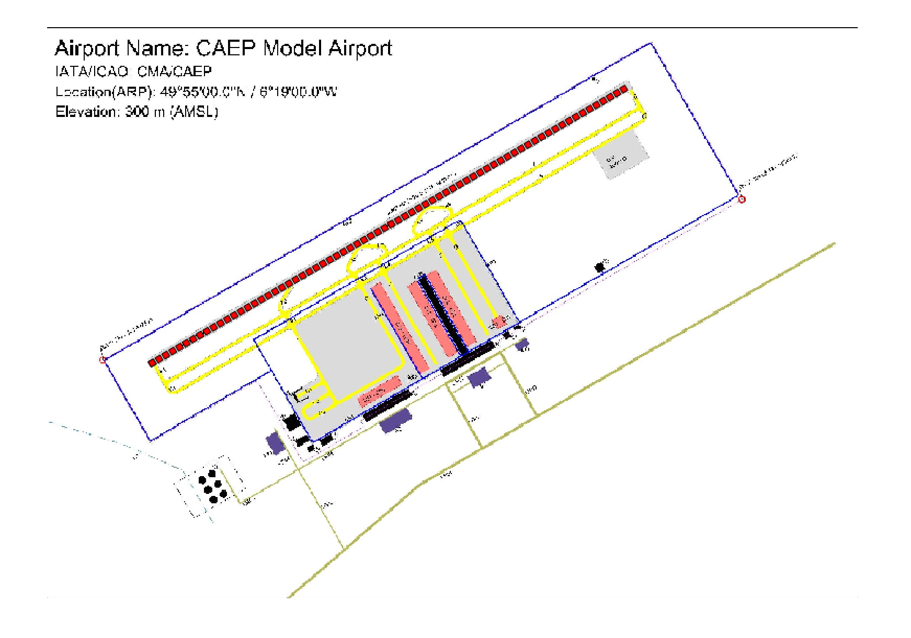

Figure 26: The runway (red marker line) of CAEPport airport (06/24) designed on top of the georeferenced airport image.

#### Add Gates

Next, we will see how to add gates. First, select the **Gates** Layer from the Open-ALAQS Layers panel. Same as above, the next step to adding a gate is to click on ***Toggle Editing*** and ***Add Feature*** from the Digitizing toolbar. Remember that gates are represented as polygons in Open-ALAQS. So, to design a gate, start by clicking on the first corner of the gate then move the pointer to the next corner and repeat until an entire polygon is defined. Then right-click and a pop-up window will appear where you should provide all the necessary information (*Gate Name, Type and Height*) as shown in Figure 27. To finalise each step, click OK and don’t forget to save each new feature.

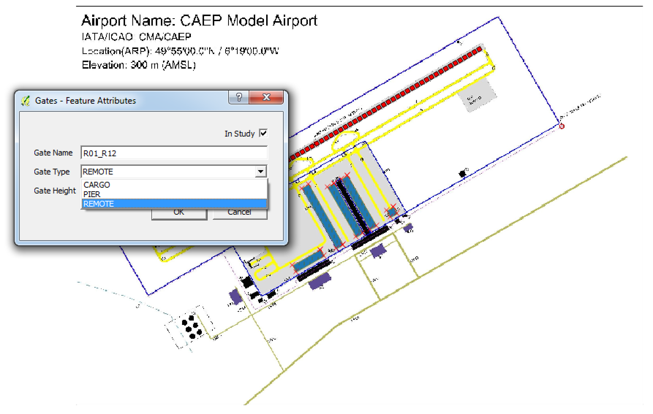

Figure 27: Creation of a gate in Open-ALAQS. The gates (blue polygons with red markers) are designed on top of the georeferenced airport image. The Feature Attributes window is also visible on the left of the image.

#### Add Taxiways

The process for adding a Taxiway is similar to the procedure described above for Runways since this source is also represented as a line. First, choose Taxiways from the Open-ALAQS layers menu then click on Toggle Editing and Add Feature from the Digitizing toolbar.

Note that when designing taxiways, we need to account for all possible aircraft movements and capture every intersection. Since taxiways will be used to connect gates and runways, it is also very useful to design taxiways as a series of segments. Remember that while it is always possible to add a new intersection at a later stage of a study, it will imply splitting an existing taxiway in two or more segments and redefining all the taxi-routes that use these segments.

Using the pointer click on the first end of the taxiway segment then move the pointer to the other end to continue (Figure 29). Right-click to finalise and save the new feature.

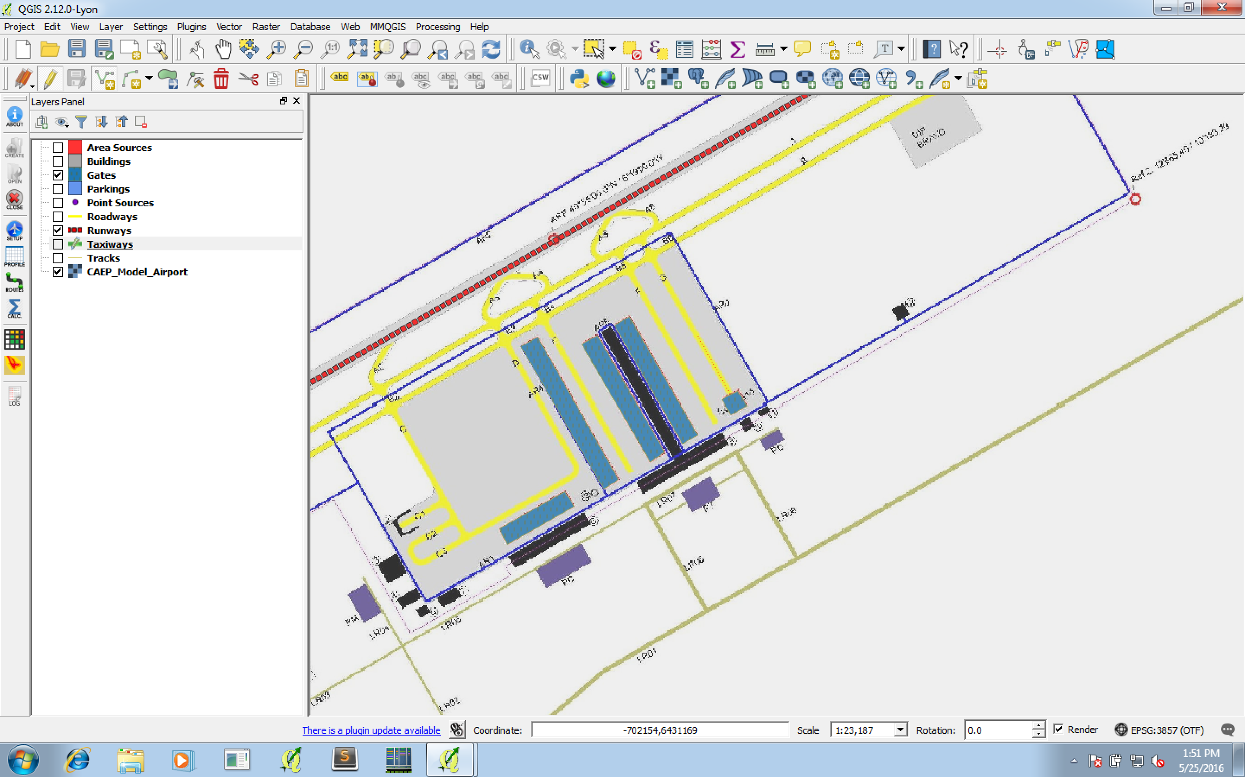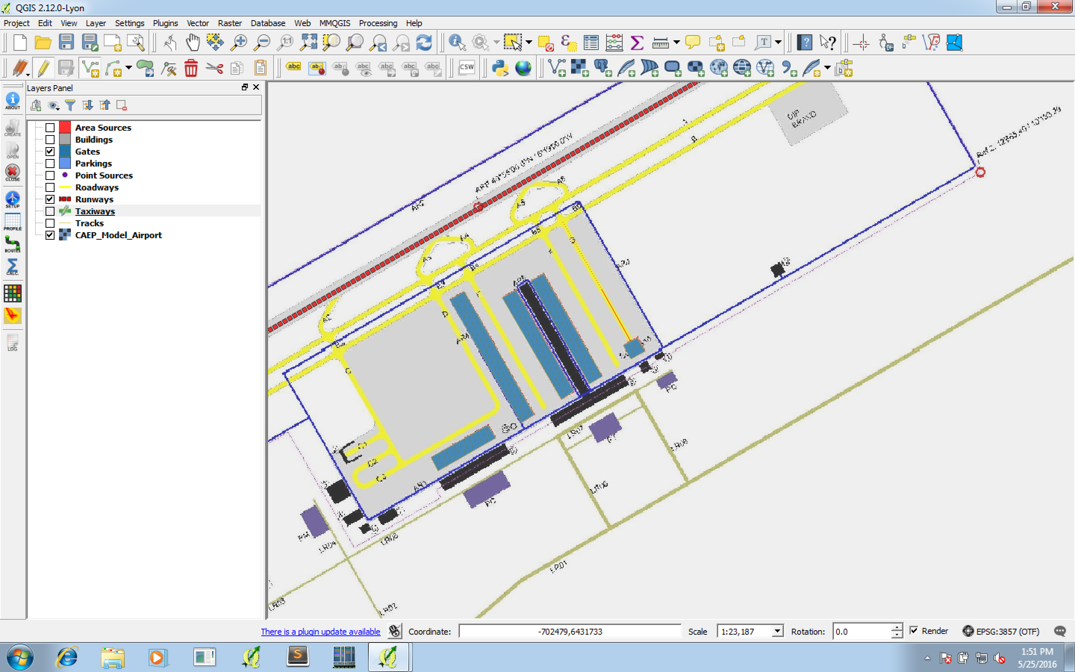

Figure 28: Building taxiways in Open-ALAQS. Each black arrow points to a segment of the taxiway (dotted red line)

Next, fill-in all necessary information (name, speed, in study) in the Taxiway Editor window that appears. Repeat the same process for the rest of the taxiways. The resulting taxiways should be similar to the ones shown in green in Figure 29**.**

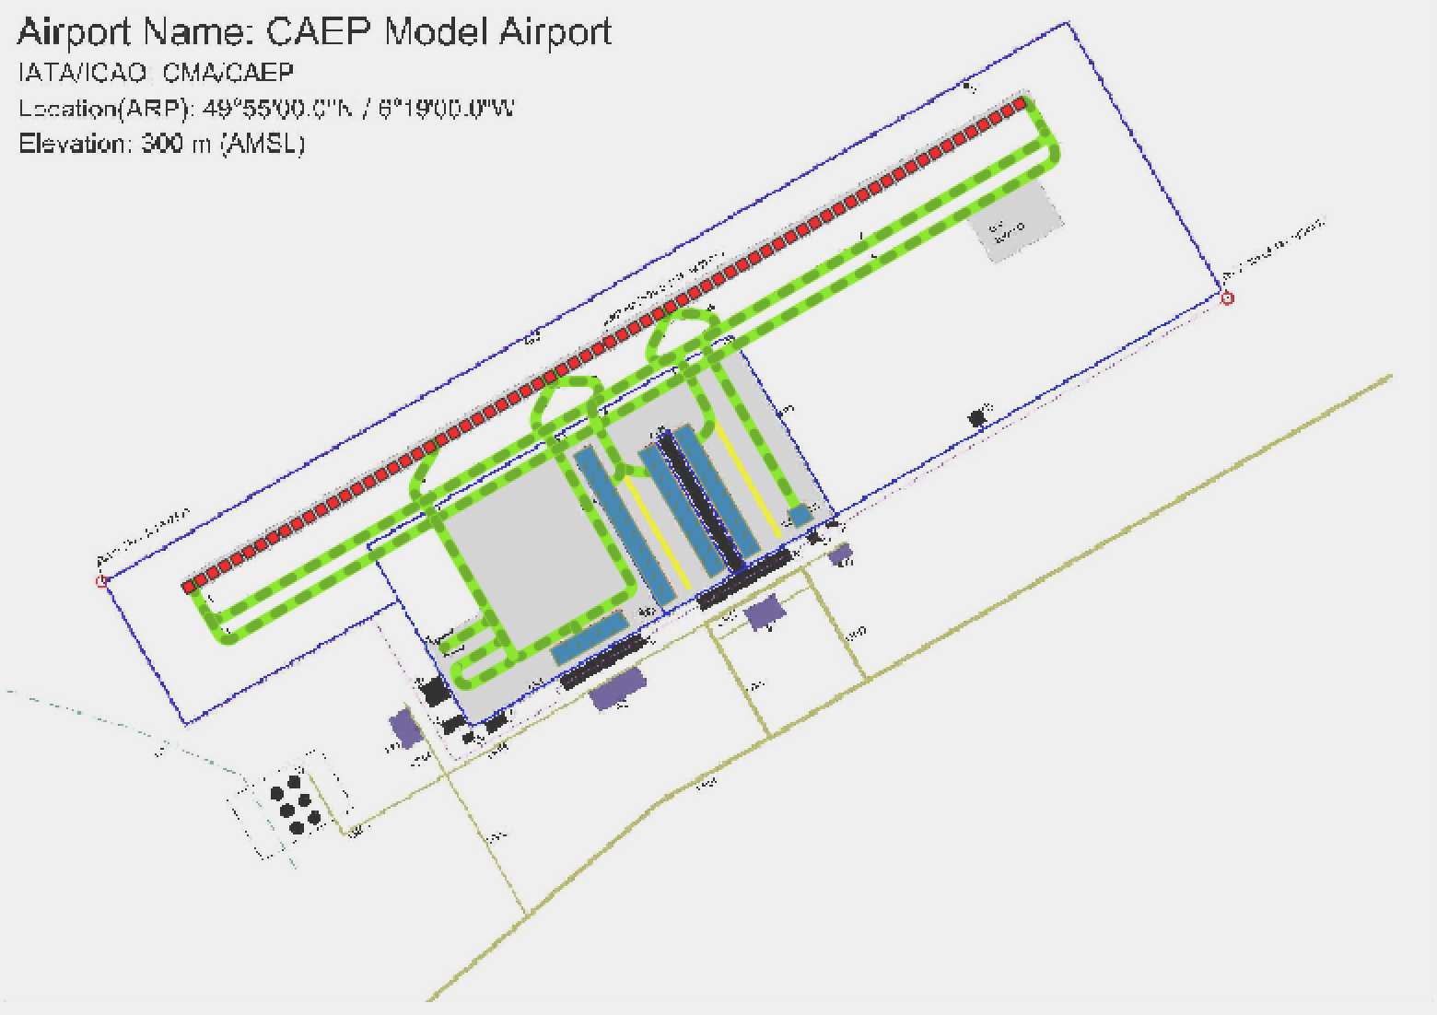

Figure 29: The ensemble of taxiways (in green) designed for this example.

Before continuing, make sure that all taxiways are well defined by ensuring that all segments are well connected and the end/starting points are touching the runway/gate.

#### Edit Attributes

In order to modify any of the attributes (name, in study etc.) of the previously designed features, the Open Attribute Table option can be used from the *Attributes* toolbar. An example of this QGIS feature is shown in Figure 30 for the gates of this test case study. Once a specific layer is selected from the Layers panel (Gates for this example) click on the Open Attribute Table (from the QGIS toolbar), a window will appear where all attributes are visible. Note that before you can edit a previously defined value, Toggle Editing has to be selected first.

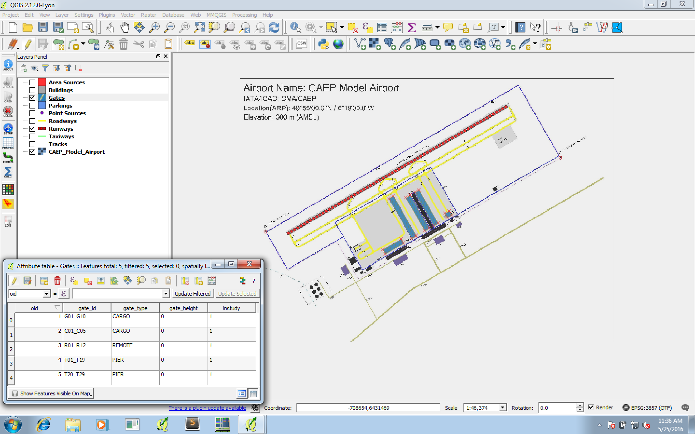

Figure 30: The Attribute Table window of QGIS is shown on the left. On the right, the 5 gates of this example are presented (in blue) as polygons.

## Add non aircraft-sources

#### Add Area sources

Area sources are designed as polygons. Select the Area Layer from the Layers menu and click on *Toggle Editing* and *Add Feature* from the Digitizing toolbar. Construct a polygon as explained above for Gates and fill-in all the necessary information (*Source Name, Parameters, Profiles and Emissions*) in the pop-up window (shown in Figure 31).

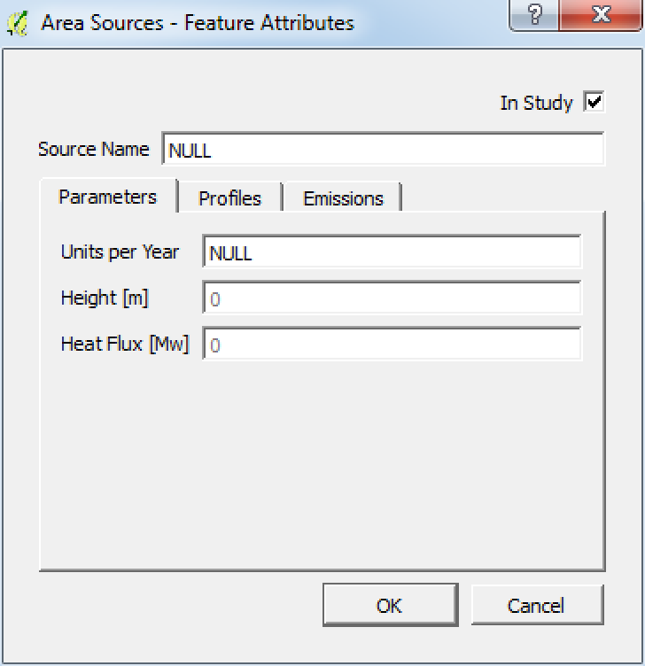 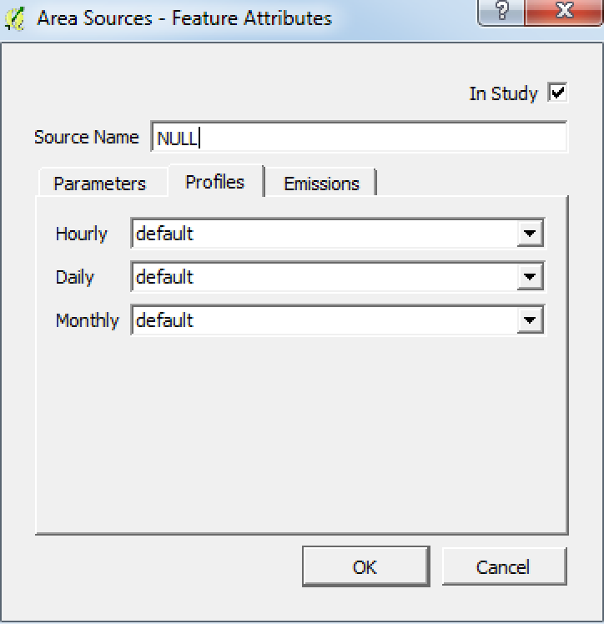 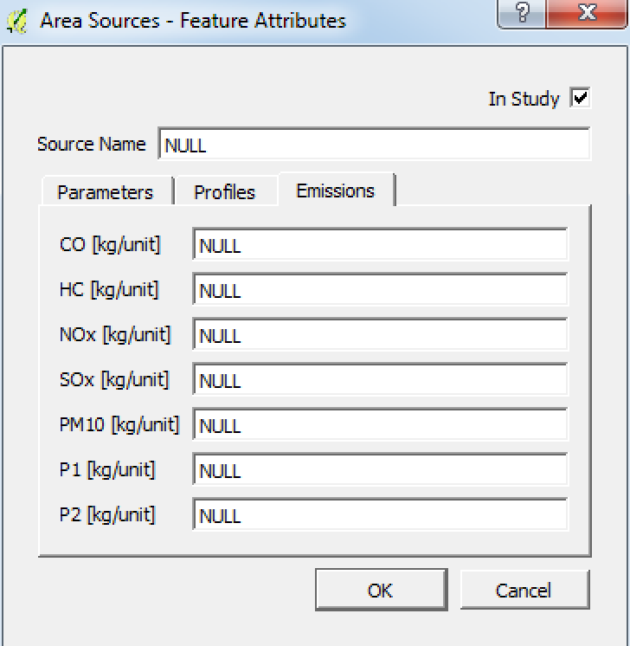

Figure 31: Feature Attributes for Area sources. The emissions factors for this type of source have to filled by the user.

For this example, 5 Area sources were designed (Figure 32).

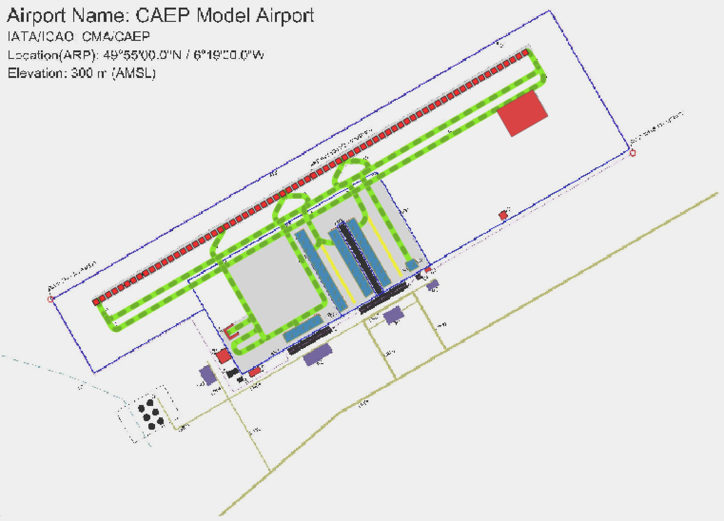

Figure 32: Area sources (polygons filled with red colour) designed for CAEPport.

#### Add Point sources

Similarly as above, we will define some Point sources for the needs of this example. Select the Point Layer from the Layers menu and click on ***Toggle Editing*** and ***Add Feature*** from the Digitizing toolbar. Click on the point that will represent this new source and fill-in all the necessary information (*Source Name, Parameters, Profiles and Emissions*) on the pop-up window. Note that for this type of source the user has to select a type category. All emission factors are automatically loaded for the selected type. Then, the only parameter that needs to be filled by the user is the number of Units/year (Figure 33).

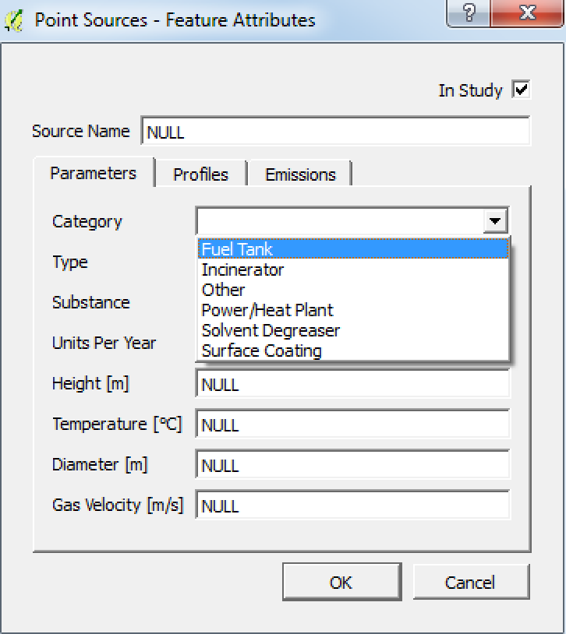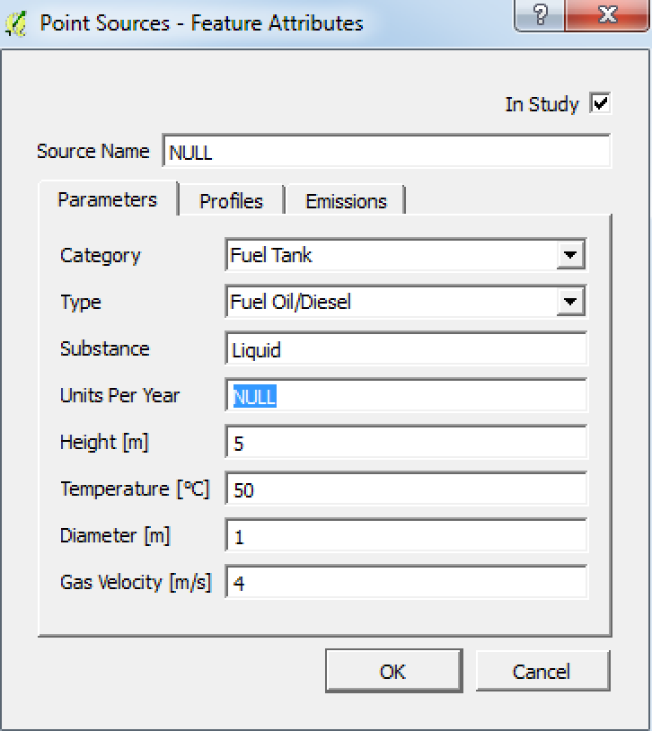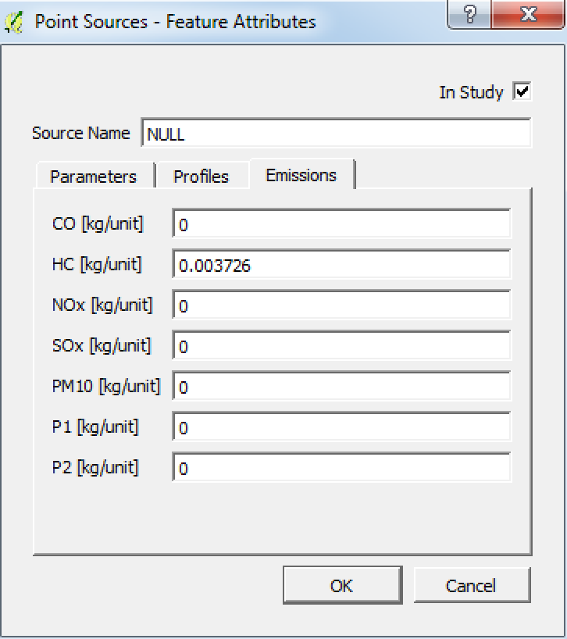

Figure 33: Feature Attributes for Point sources. The type of source and the number of units per year have to filled by the user.

It is also possible to include a custom type by selecting “Other” from the *Category*ComboBox (Figure 34).In this case all necessary attributes will have to be filled manually by the user.

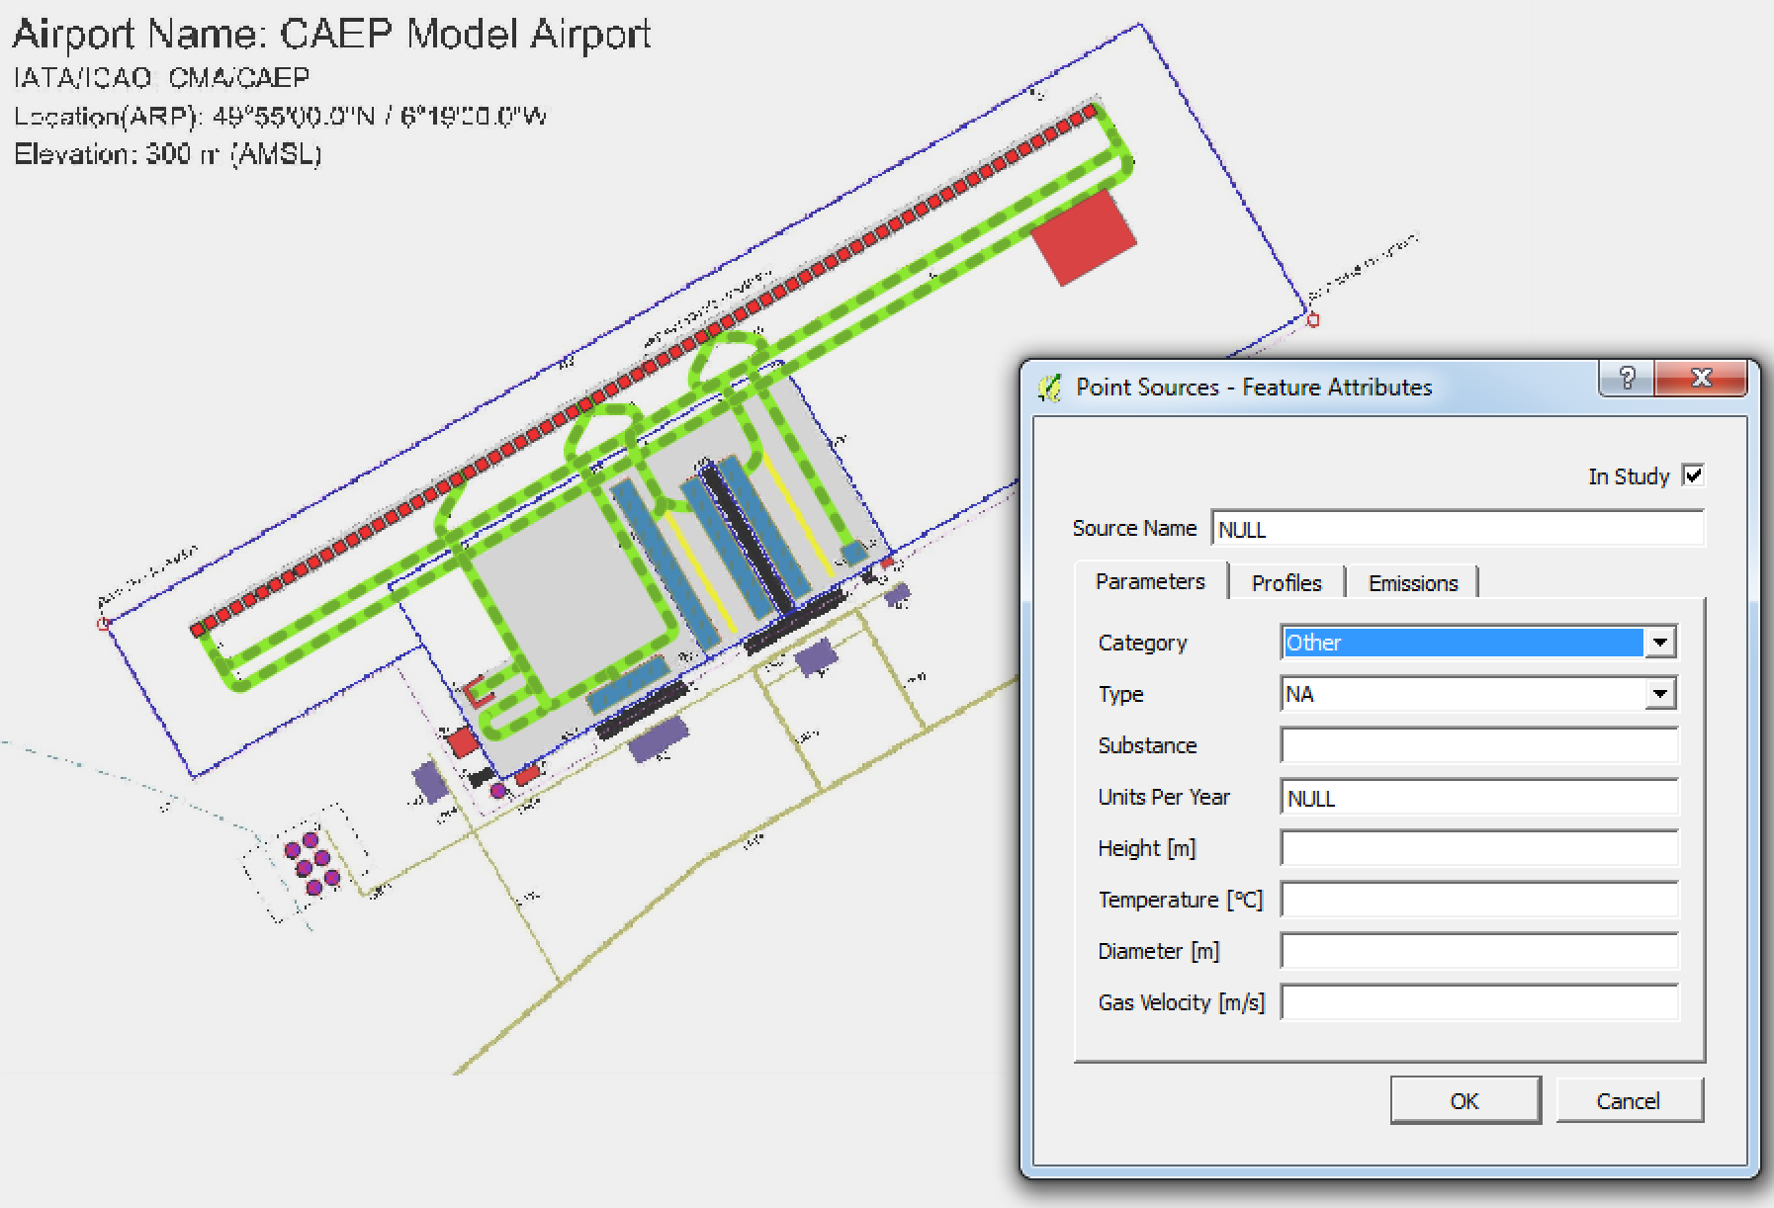

Figure 34: Point sources (shown in violet) and the corresponding Open-ALAQS Point Sources window.

#### Add Buildings

Since Buildings are also represented by polygons in Open-ALAQS the procedure for adding this type of feature is similar to Gates or Area sources.

Select the Building Layer from the Layers menu and click on ***Toggle Editing*** and ***Add Feature*** from the Digitizing toolbar. Construct a polygon as explained before and fill-in all the necessary information in the pop-up window. As discussed in section “Stationary (Non-Aircraft) Sources”, buildings do not emit any pollutants. The only parameter that needs to be filled by the user in the Building Editor that appears is the building’s name and height (in meters) as shown in Figure 35.

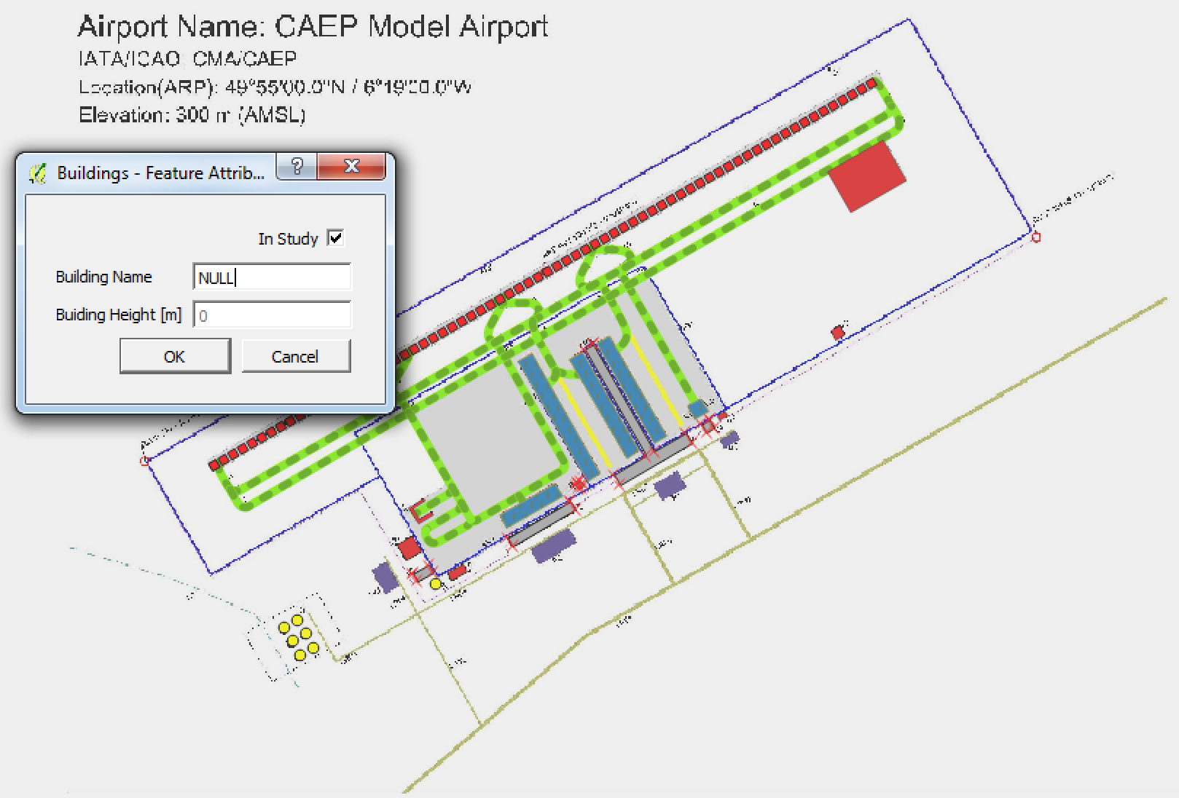

Figure 35: Buildings (shown in grey) and the corresponding Open-ALAQS Building Editor window.

#### Add Parking Lots

Parking lots are also polygon-shaped features in Open-ALAQS. To add a parking lot, select the Parking Layer from the Layers menu and click on ***Toggle Editing*** and ***Add Feature*** from the Digitizing toolbar. Design your polygon and fill-in all the necessary information in the pop-up window.

Remember that the height and Average Parking Time parameters are disabled in this Open-ALAQS version and are not used in the calculations. The idle time has to be set as well as the fleet mix (PC, LDV and HDV vehicles). Regarding emissions, the corresponding emission factors have to be calculated for the selected configuration. Click on the Recalculate button (from the Emissions tab) to update the emission factors fields as shown in Figure 36.

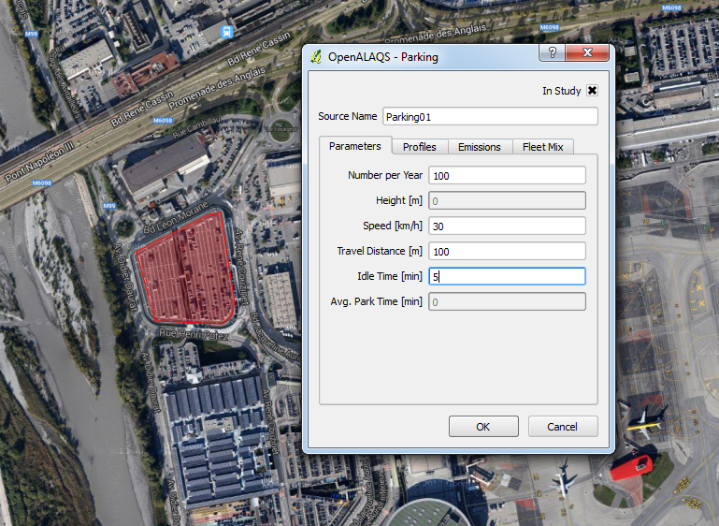 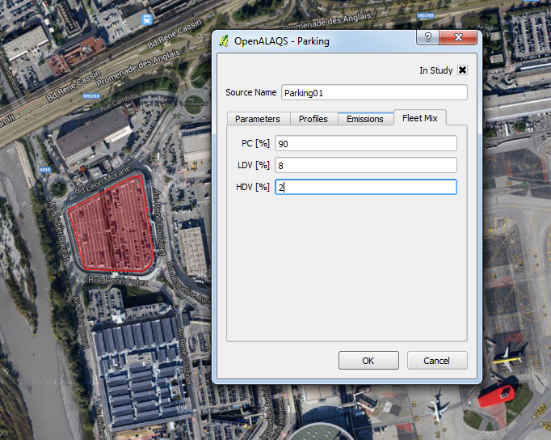 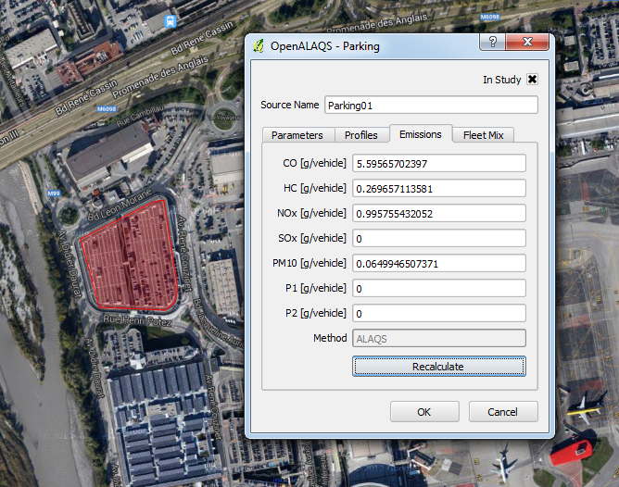

Figure 36: Open-ALAQS Parking Editor (Parameters, Fleet Mix and Emission factors) window.

The parking lots designed for this example are shown in Figure 37.

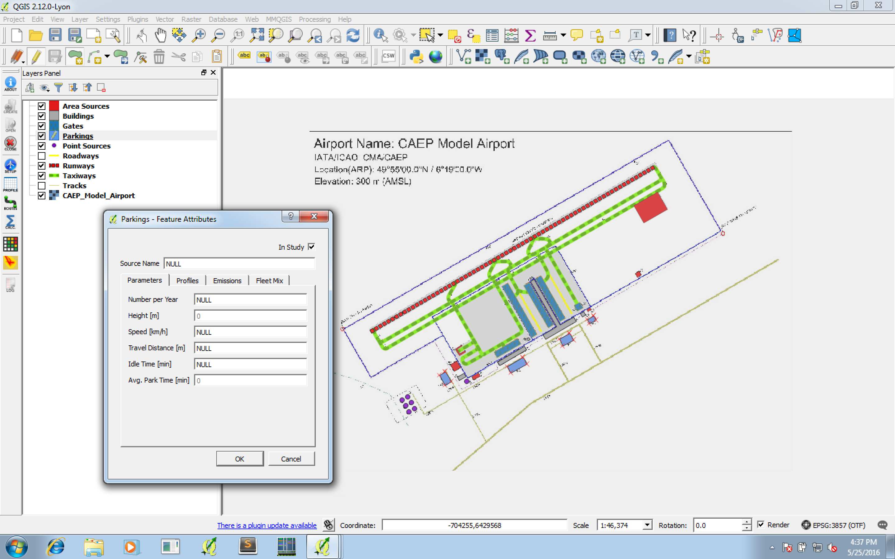

Figure 37: Parking lots (shown in blue with red markers) designed for CAEPport.

#### Add Roadways

Roadways are represented as a line in Open-ALAQS. To add a new roadway, select the corresponding Layer from the Layers menu and click on ***Toggle Editing*** and ***Add Feature*** from the Digitizing toolbar. Design your line and fill-in all the necessary information in the pop-up window.

The number of movements per year as well as the speed (in km/h) and fleet mix (PC, LDV and HDV vehicles) have to be set in the Parameters and Fleet Mix tabs respectively. Then, the corresponding emission factors can be calculated for the selected configuration. Click on the Recalculate button (from the Emissions tab) to update the emission factors fields (Figure 38). The roadways designed for this example are shown in Figure 39.

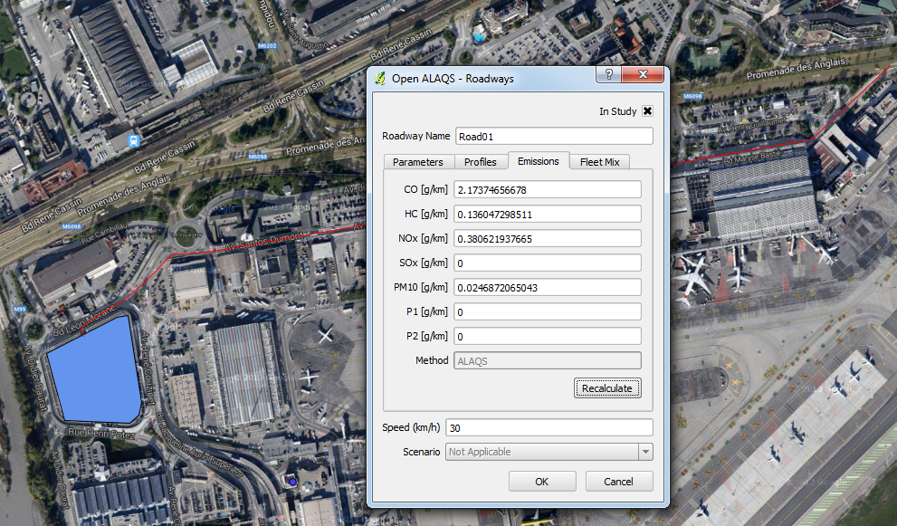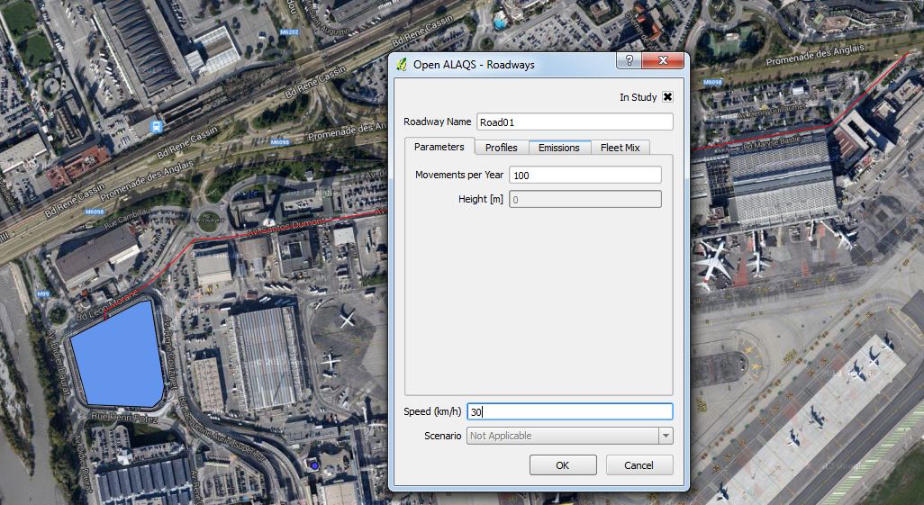

Figure 38: Roadways Open-ALAQS editor showing the Parameters and Emission factors tabs.

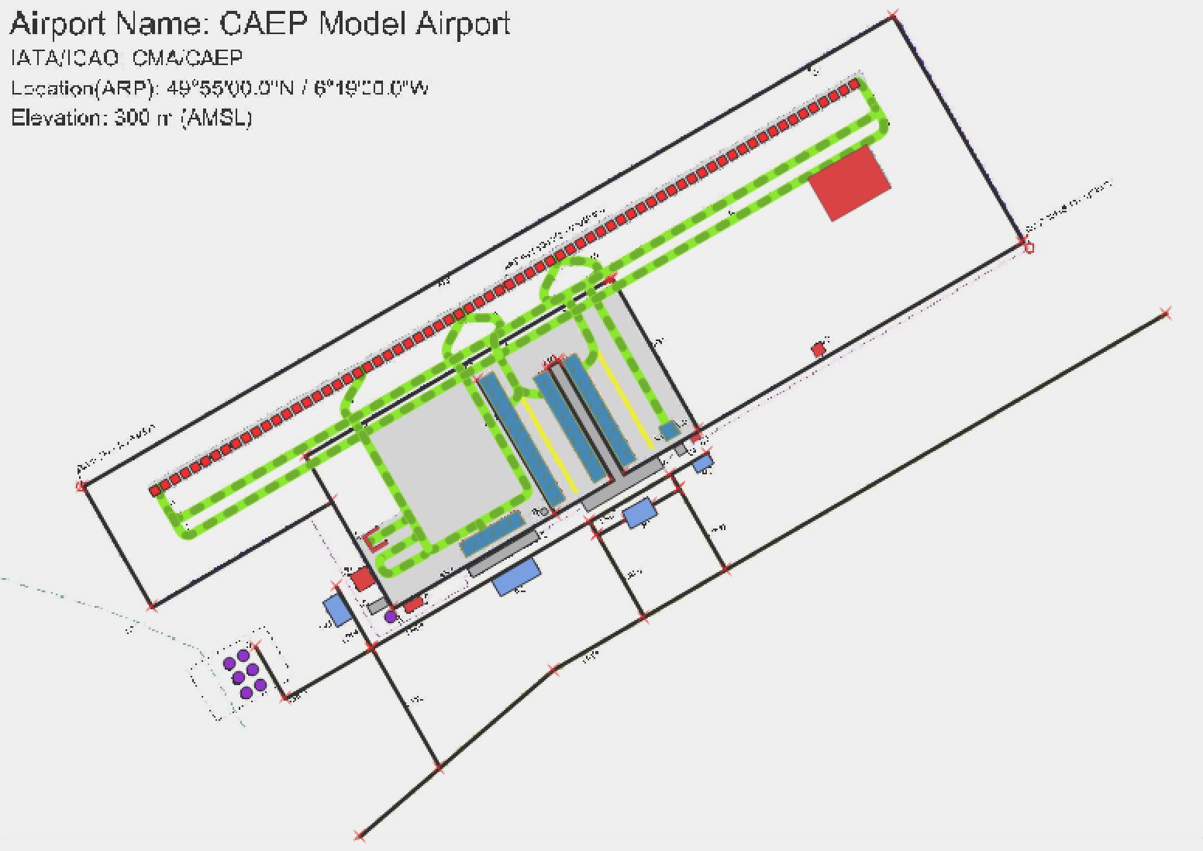

Figure 39: Roadways (shown in black) designed for CAEPport.

## Calculate Taxi-routes

Before calculating the corresponding emissions for all designed sources, we need to define the taxi-routes. Taxi-routes describe the path that will be followed by an aircraft from a runway to a gate for each movement (arrival or departure). More than one taxi-route can be defined between a runway and a gate to reflect more precisely the airport's operations (for example fast exit taxiways).

In order to create taxi routes, click on the ***Define taxi routes*** icon which can be found in the Open-ALAQS toolbar. A new window will appear (Figure 40) where a new route can be defined by combining different taxiways. Alternatively, an existing taxiway can be imported.

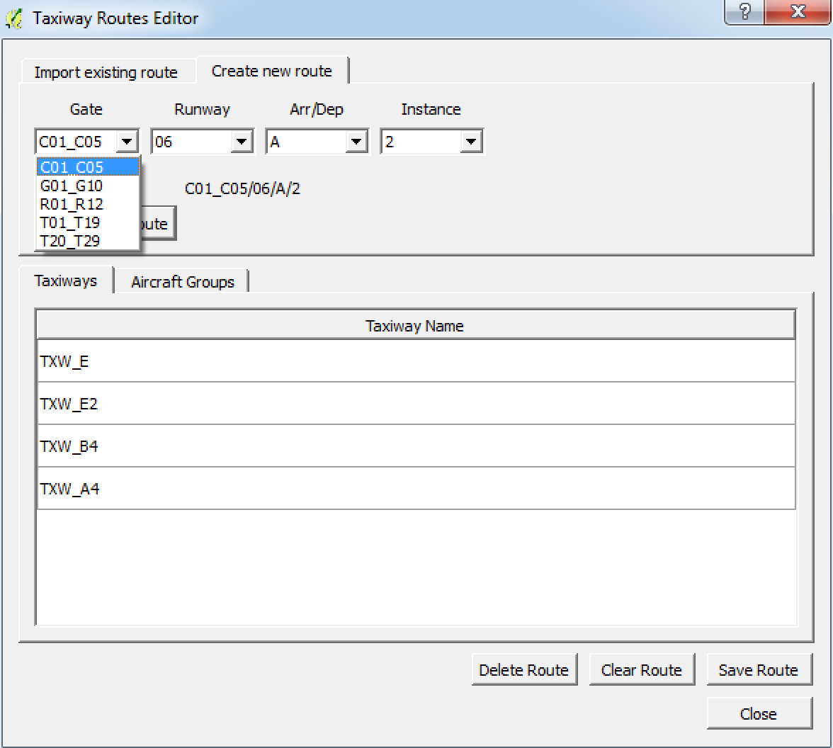 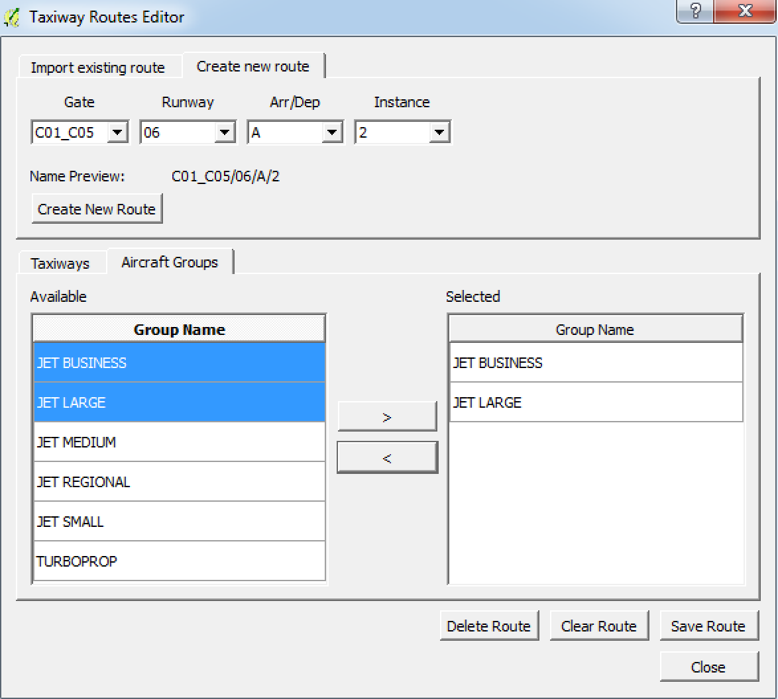

Figure 40: The Taxiway Routes Editor can be used to create a new or import an existing taxi route.

The first step to make sure that the “***Taxiways***” layer and “***Select Single Feature***” are selected. In order to create a new taxi-route choose a specific gate (*Gate*), a runway (*Runway*) and define whether the route is used for arrivals or departures (*ARR/DEP*). This can be done from the “***Create new route****”* tab. If there is more than one possible route for a specific gate/runway, provide a different number (*Instance*) in order to distinguish them. To define a taxi-route that is made up from several taxiway segments, simply hold down the ***ctrl*** button and select the appropriate taxiway segments. Once the path is defined, the aircraft types that are going to use this taxi-route need to be specified. Click on “Aircraft Groups” tab and select the appropriate aircraft types from the “*Available*” Group Name to “*Selected*” Group Name. When done, click on “Save route” to save this work.

## Generate Emission Inventory

When all emissions sources and routes are defined, the construction of the corresponding emissions inventory can be realised. Click on the **Calculate Emissions Inventory** icon from the Open-ALAQS toolbar and a new window will appear (Figure 41) where we need to provide a *movements table* anda *meteorology* fileanddefine the *Output Save Name* and *Path.*

Using the Browse Movements Table button, select the movements file (**caepport_movements.csv)** that is included in the example folder. Similarly, select the meteorology file (**caepport_meteorology.csv**). The vertical limit is set by default to 914.4 meters and the Towing speed is predefined at 10 km/h. Finally, set the resolution of the modelled and click on the *Create Inventory* button to generate the **“.alaqs”** output file.

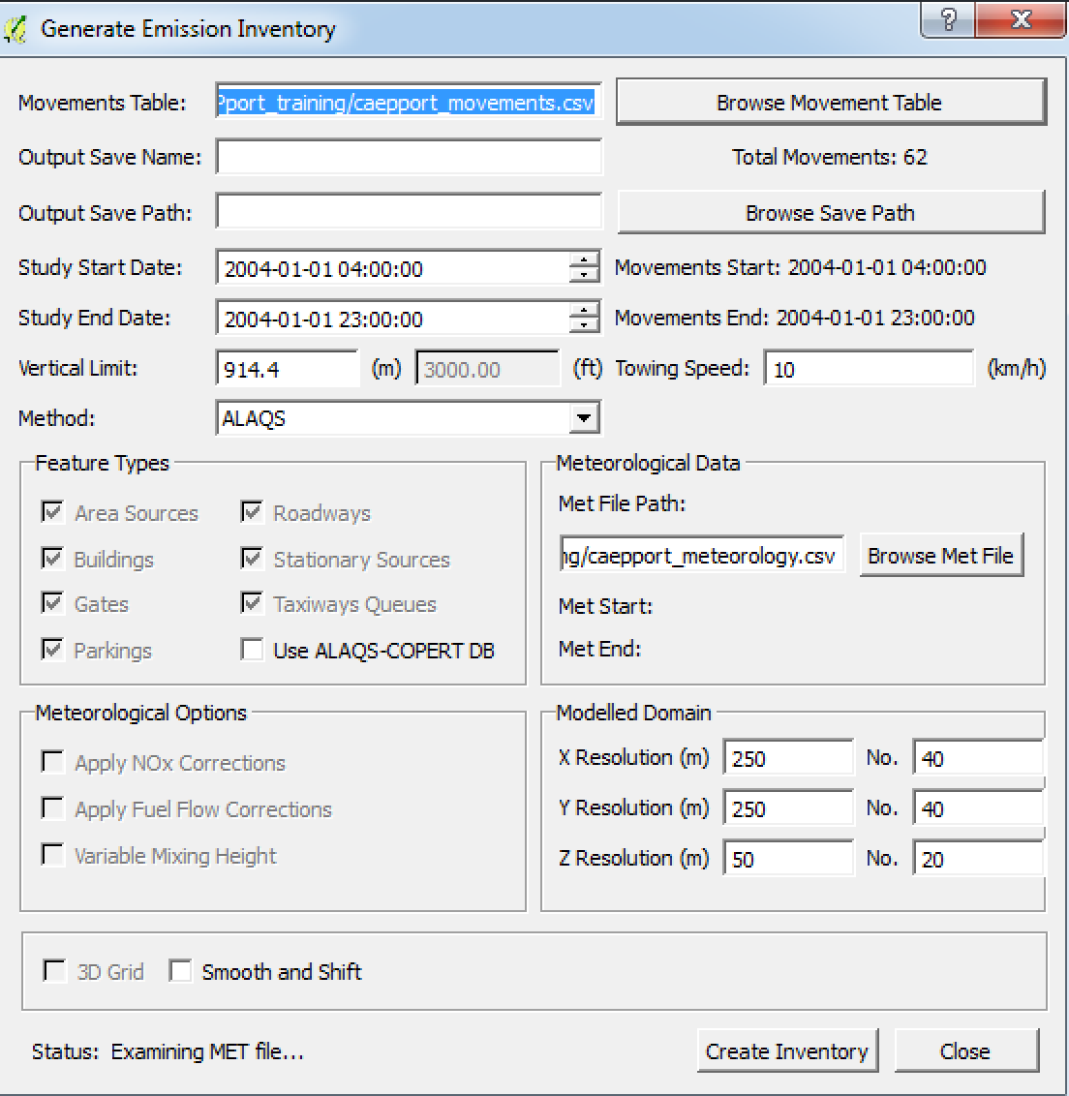

Figure 41: Generate Emission Inventory window. The user needs to import a Movement Table, meteorological data and provide the name and path for the output file.

When the calculation is completed, a dialog box will appear informing the user of the successful creation of the output file.

## Calculate & Visualize Results

In order to calculate the emissions for the designed sources, click on the Visualise Emission Calculation icon from the Open-ALAQS toolbar. A window will appear (Figure 42) where you need to specify the output file that you want to explore. Click on *Browse* to select the file you created for this case study. Then select the source type and name of your choice. Once the source is selected you will need to select a calculation method from the “Emission *Calculation*” tab. If desired, the source dynamics can be taken into account by selecting the appropriate method from the same tab. Finally, choose one of the following output modules to calculate the emissions (per hour):

* Emissions Table
* Plot Timeseries
* Export to CSV
* Plot VectorLayer
* Export to DB

If the module “Export to CSV” or “Export to DB” is chosen, the path and file name will have to be specified. Emissions can be visualised by selecting any of the other three output modules. Figures 43 and 44 present the results in *table* and *vectorlayer* format respectively for all aircraft movements of this test case study.

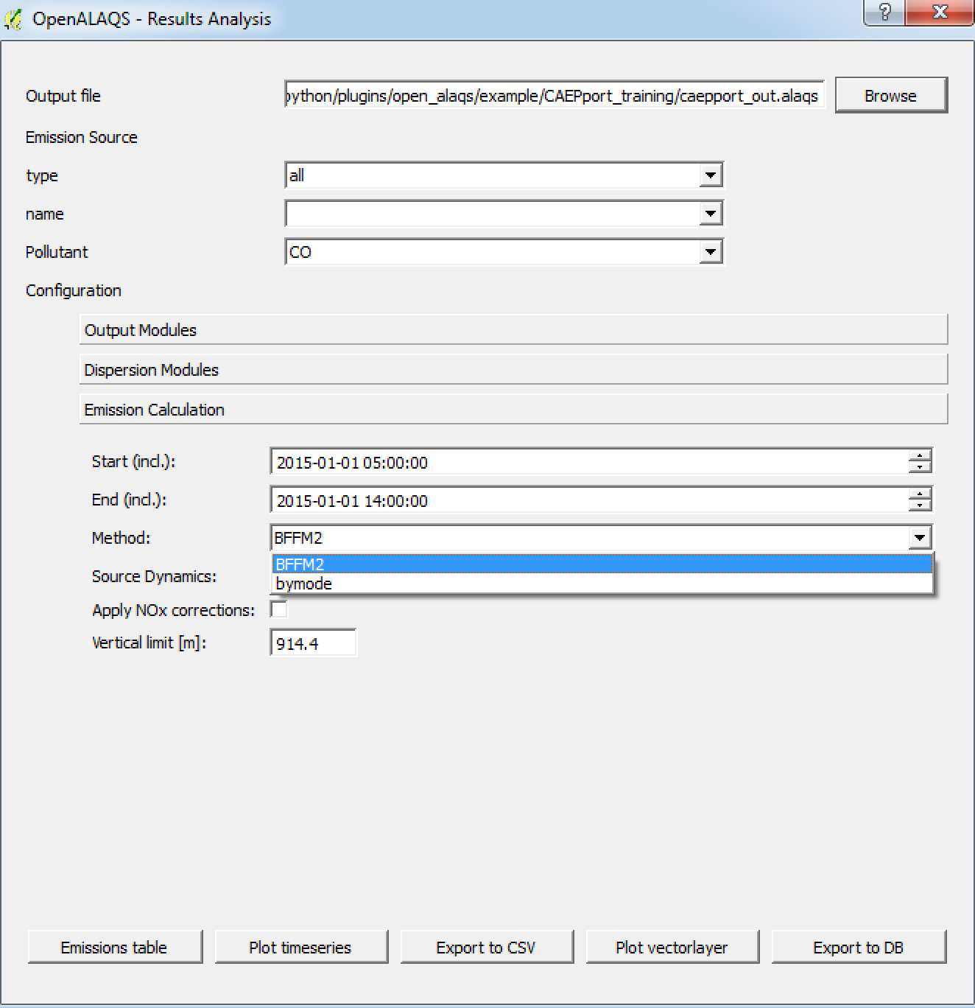 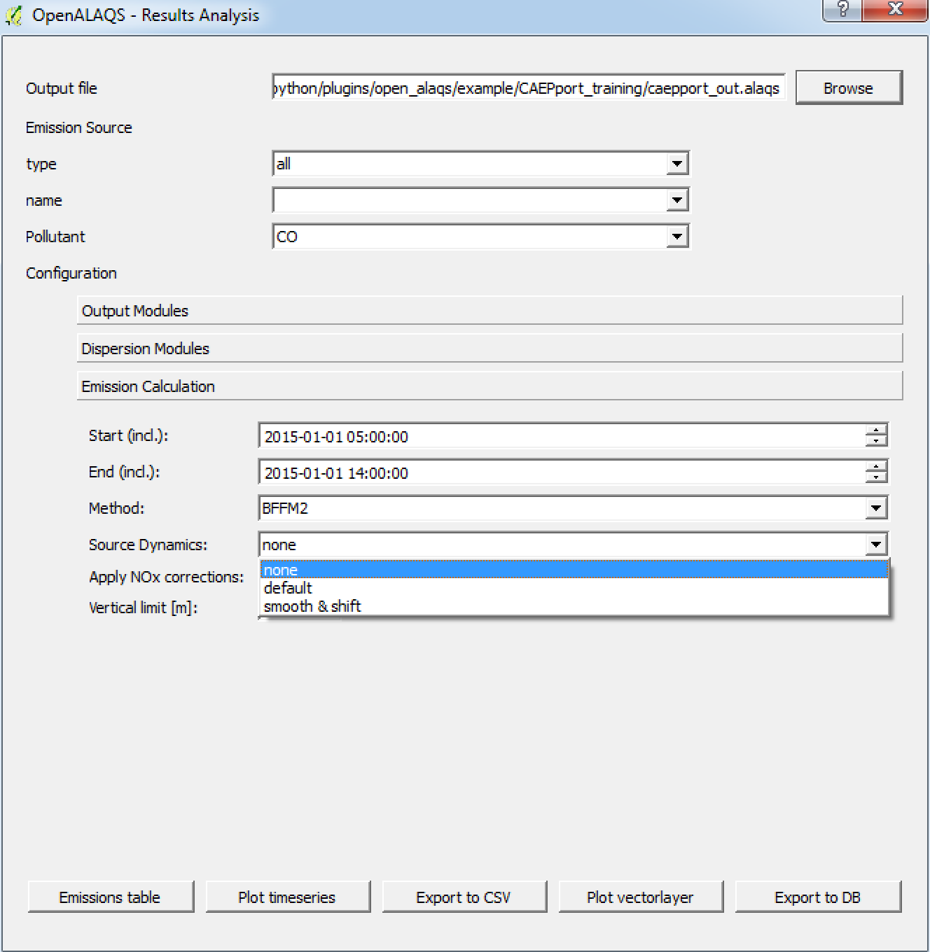

Figure 42: The Open-ALAQS *Explore Results* window. The user can browse an output file, select a calculation method and see the calculated emissions for a specific source.

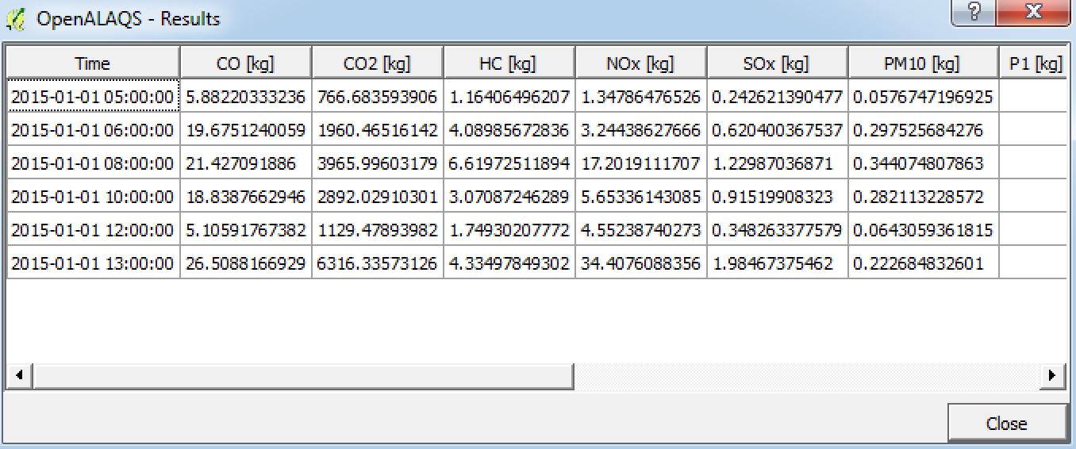

Figure 43: Results shown in a table format for all the aircraft movements in the provided movements file.

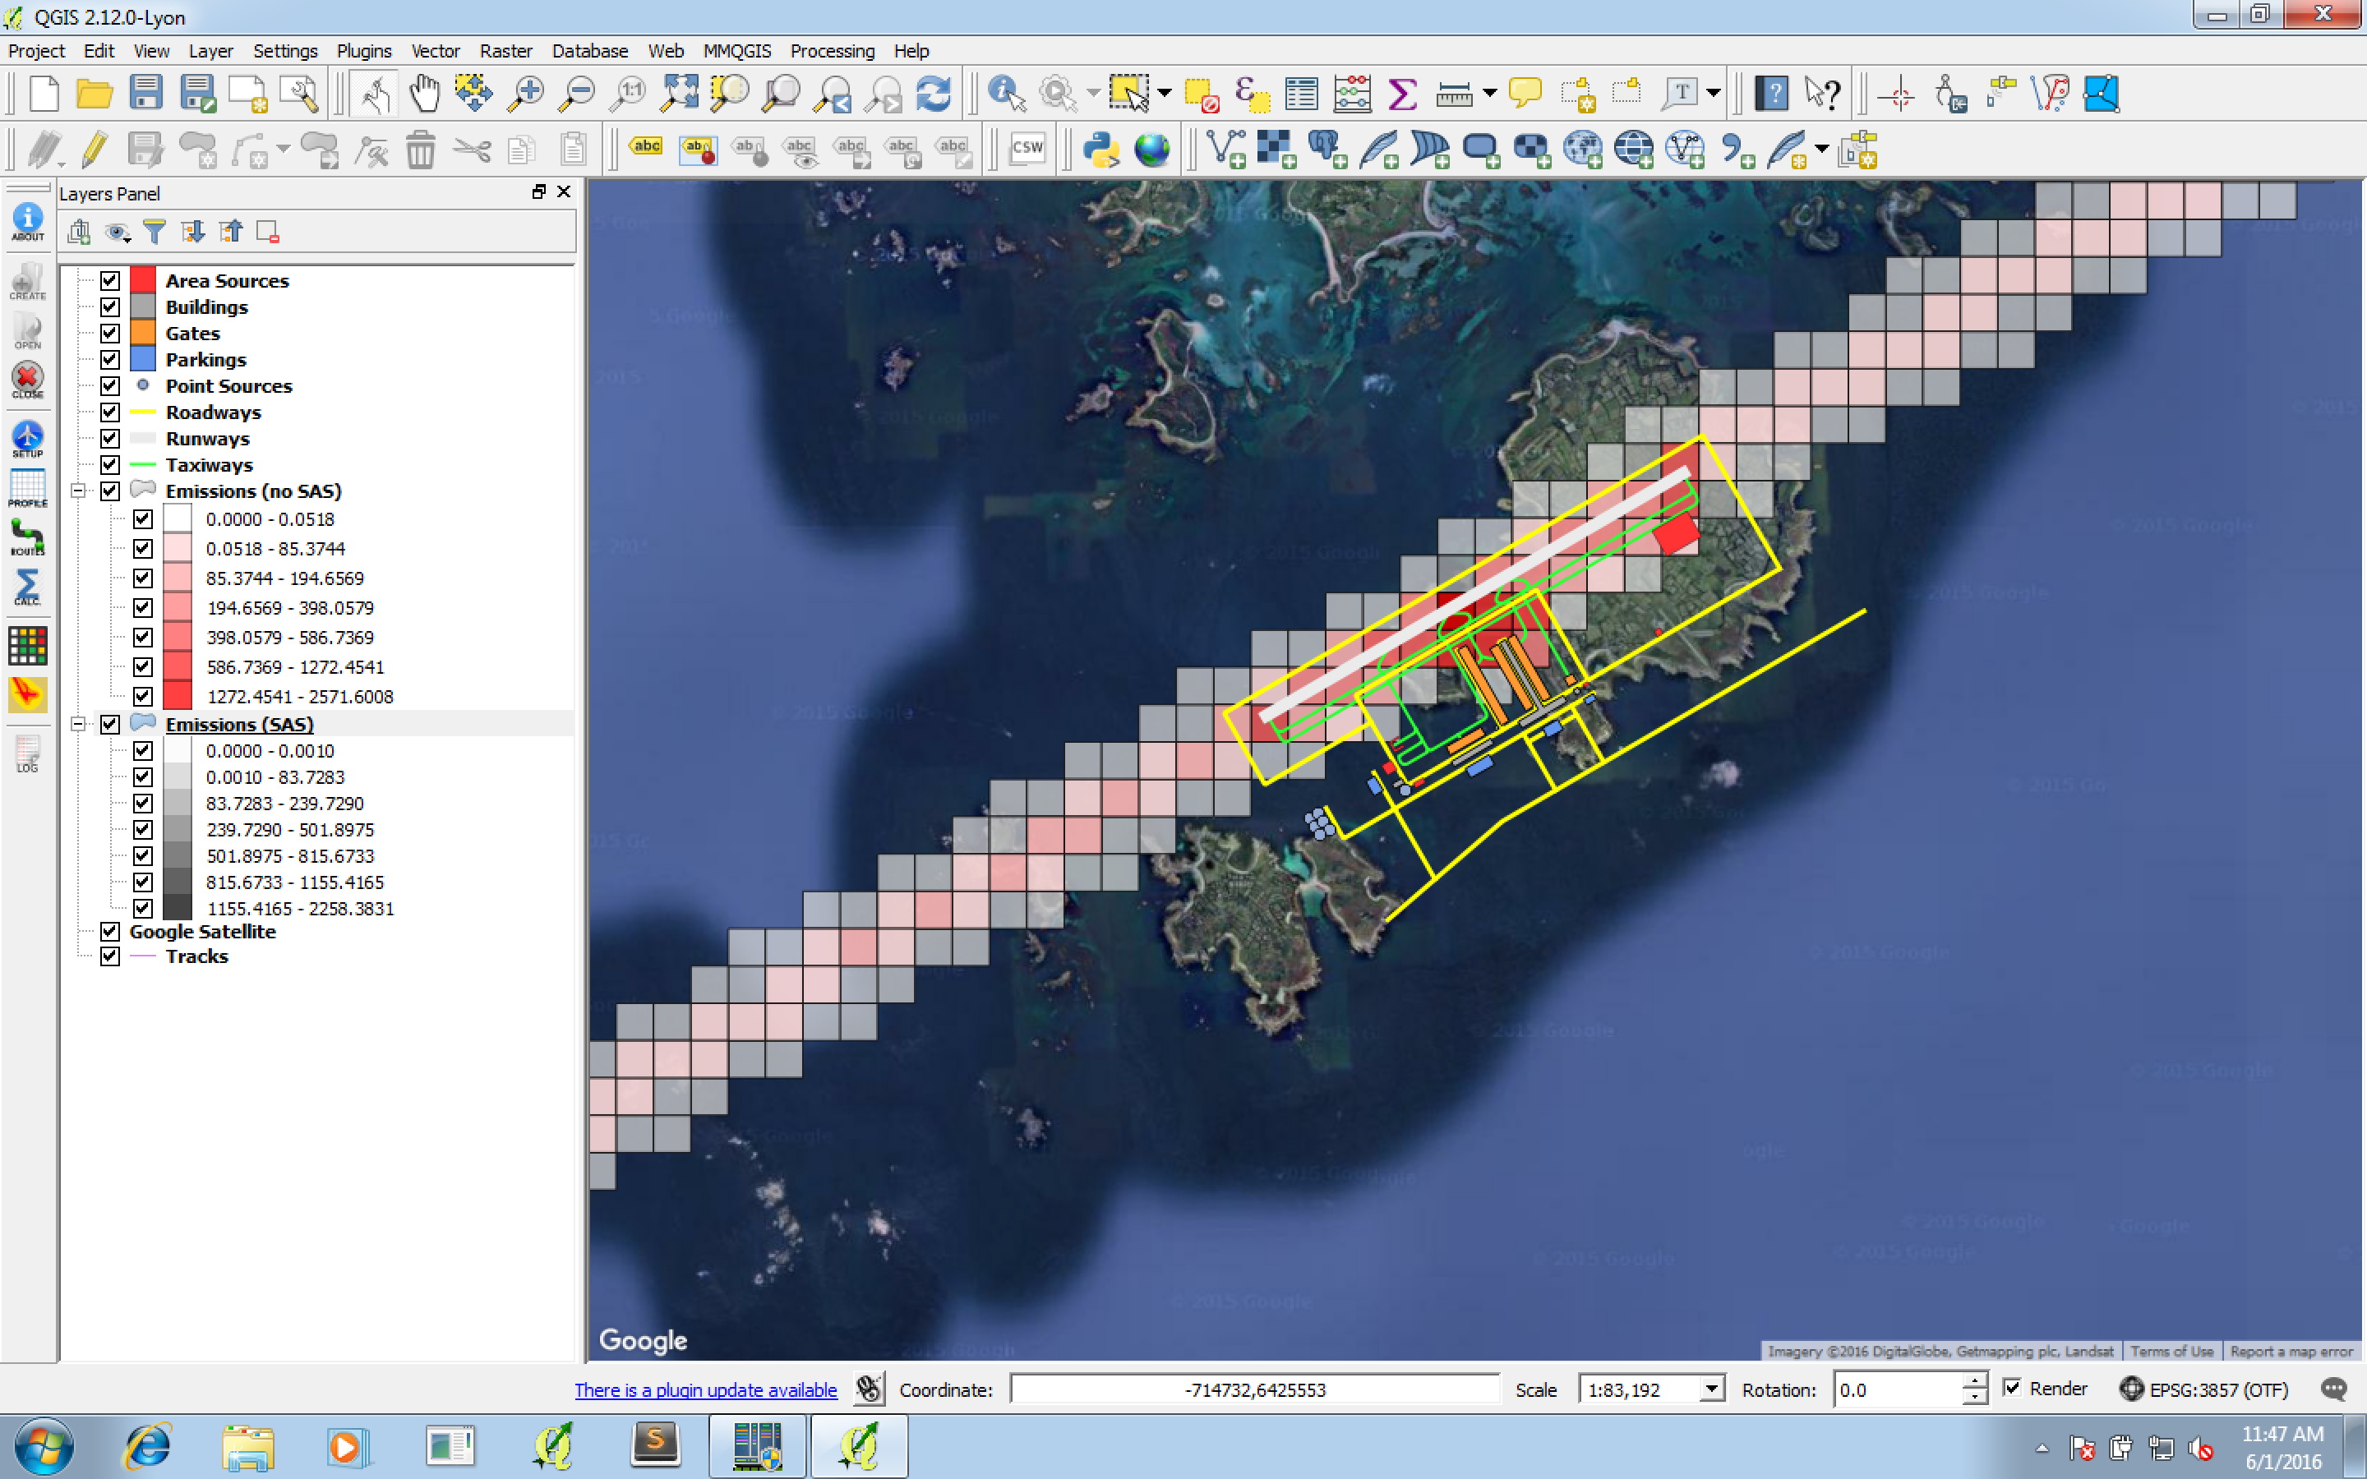

Figure 44: Results shown as a vectorlayer (red: without accounting for emission dynamics, grey: using the Smooth & Shift approach) for all the aircraft movements in the provided movements file.

## Prepare AUSTAL2000 Input Files

In order to activate the AUSTAL2000 module, click on “enable” in the AUSTAL2000 tab (under Dispersion Module) as shown in Figure 45.

Default values have been given to all key parameters to ensure a successful simulation in case of missing data. The only field that will have to be completed is “add title”. Type a title (for example “CAEPport”) and then add “Average=1” to the “options string” as shown in Figure 45 in order to obtain hourly values of concentrations (for later use).

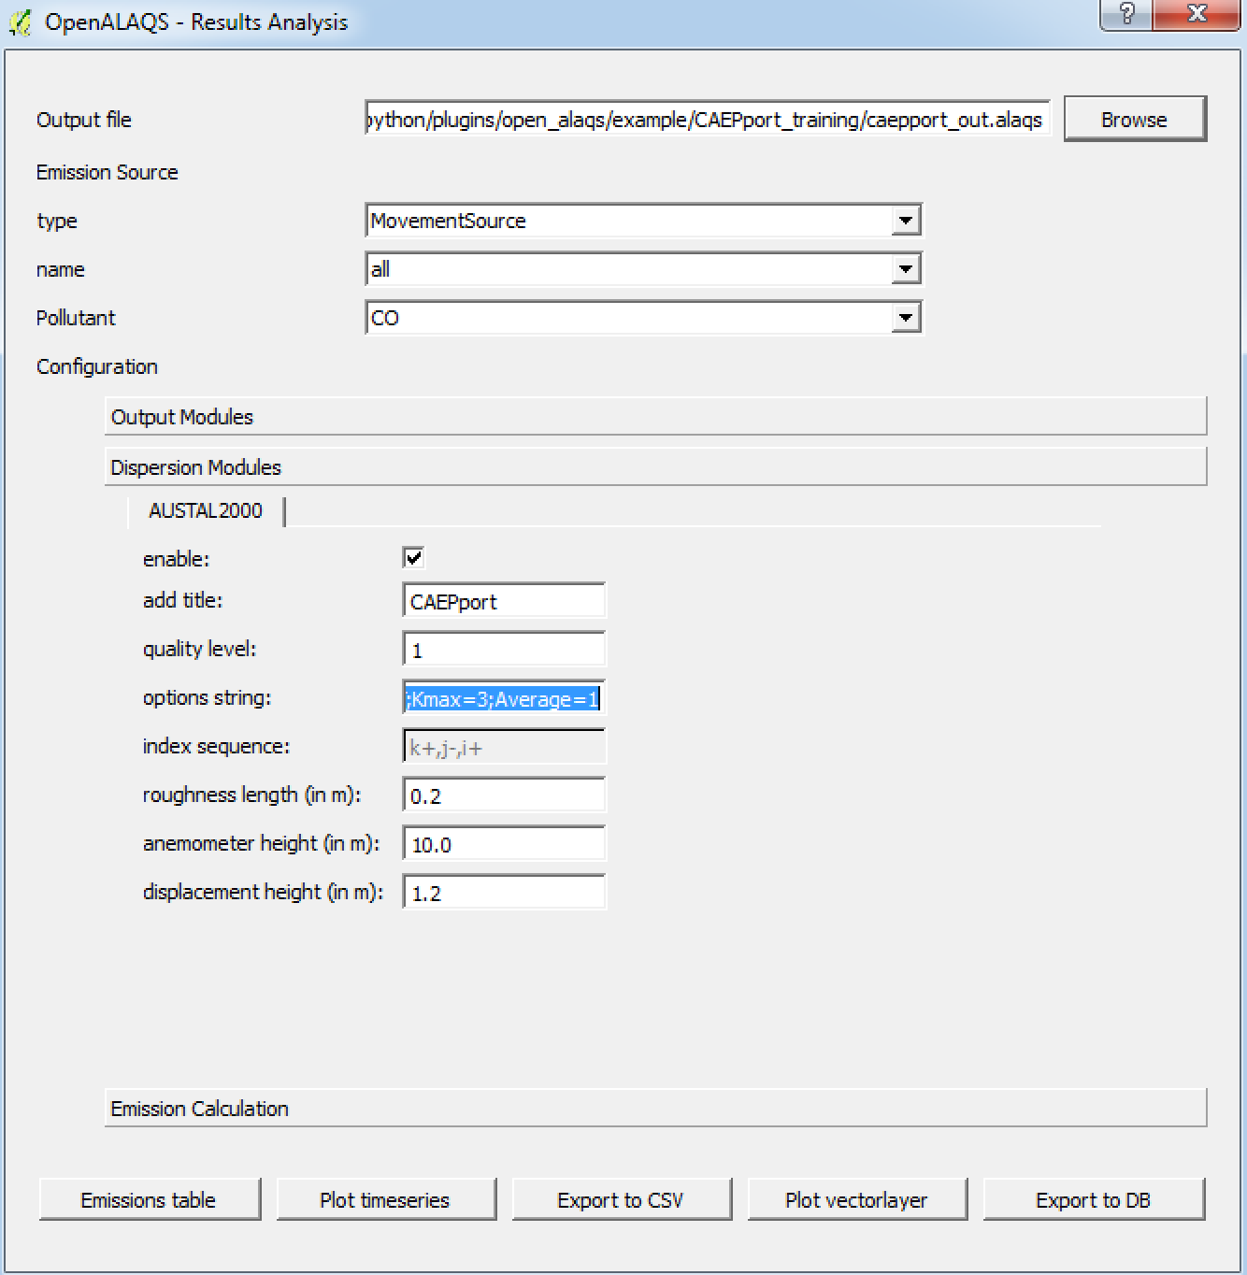

Figure 45: AUSTAL2000 module

The last step is to choose an Open-ALAQS output module. A new window will appear in order to specify the path towards the directory where the input files will be saved. All input files for AUSTAL2000 will be prepared at the same time as the calculation of emissions in Open-ALAQS for the selected emission source type(s) and for all pollutants. A progress bar will appear in order to provide information about the progress of the whole process (emissions’ calculation and preparation of AUSTAL2000 input files).

## Run AUSTAL2000

Once all input files have been created as mentioned above, the “Run AUSTAL2000” module can be used to launch a dispersion simulation. The launch button for the module is located in the Open-ALAQS toolbar.

For a simulation with AUSTAL2000, specify the path to the AUSTAL2000 executable (austal2000.exe) as well as the path to the work directory where all output files will be written (as shown in Figure 46). The “working directory” can be the same as the directory containing the input files. By default, a file named austal2000.txt is written at the end of the calculation. If the Option –D is activated, any existing austal2000.txt file in the directory will be overwritten.

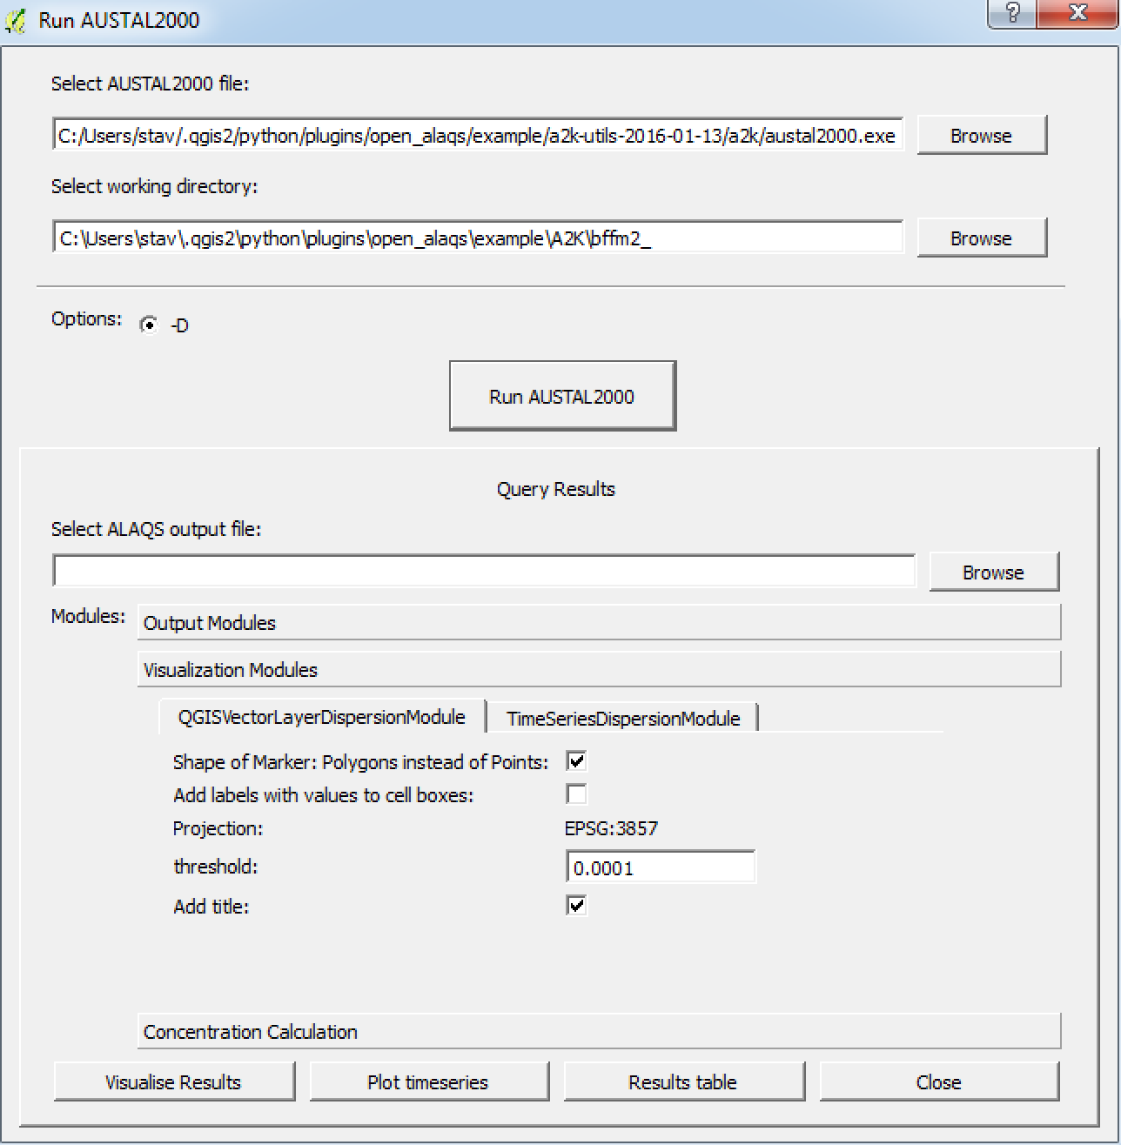

Figure 46: The "Run AUSTAL2000" window. It can be used to run a dispersion simulation but also to visualise the results.

A pop-up window will appear where information about the simulation including the progress of the process is displayed (Figure 47).

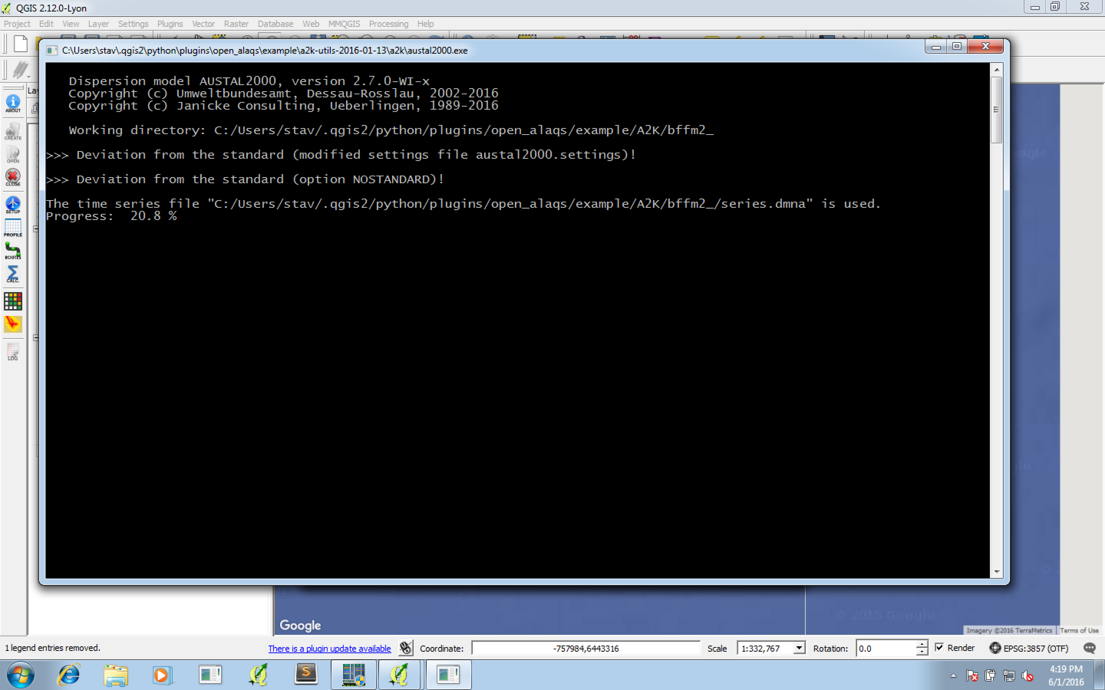

Figure 47: Pop-up window of AUSTAL2000. Information about the simulation is displayed in real-time.

## Visualize AUSTAL2000 Results

The same module can be used independently to explore or visualize the outputs of an AUSTAL2000 simulation. To explore the results of a simulation, the initial Open-ALAQS file used for the calculation has to be selected in order to load the exact grid and date used. The “Start” and “End” date fields are updated automatically when the file is imported.

The next step is to select an averaging period as shown in Figure 48. Once the period is selected, two options are possible. By default, the mean concentration for the whole grid is returned. However, the maximum concentration of the whole grid can be also made available. This is achieved by activating the “max. values” box (shown in Figure 48). In addition, the uncertainty in the calculations can be visualized if the uncertainty box is enabled.

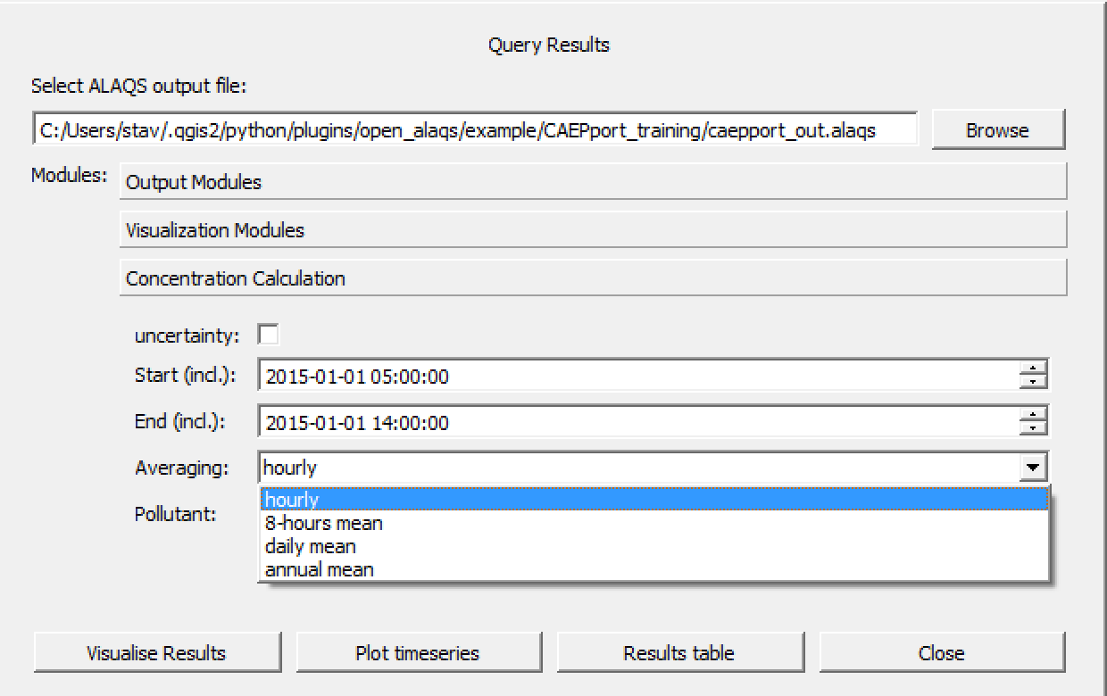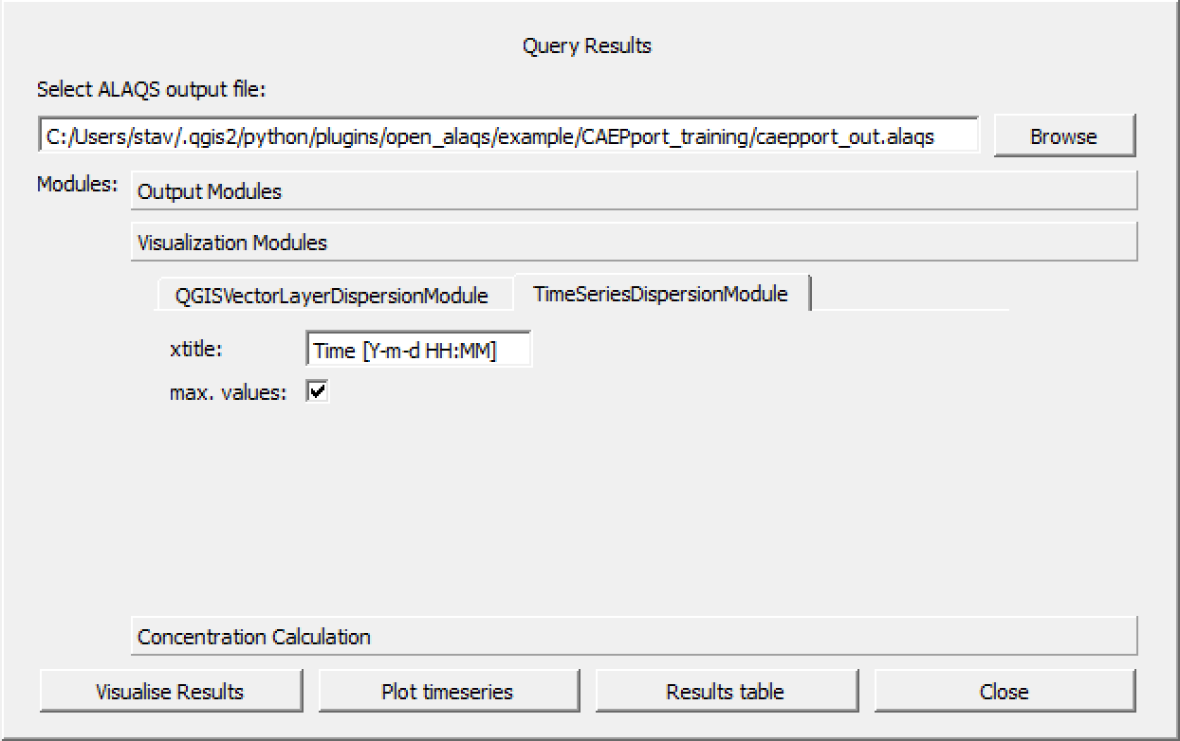

Figure 48: The “Concentration calculation” tab within the “Run AUSTAL2000” used to reshape calculated concentrations in the desired output format. The maximum concentration can be shown if the “max. values” parameter is checked (here shown for the Timeseries output module).

Finally, results can be shown in one of the following ways:

* TableViewDispersionModule (includes CSV module)
* TimeSeriesDispersionModule (see Figure 49)
* QGISVectorLayerDispersionModule (see Figure 50)

If the “TableViewDispersionModule” is selected results can be exported at the same time in .csv format if the corresponding box is activated. This is done in order to optimize the computation time.

The “TimeSeries" output module can be used for all averaging periods except annual mean where only one value is returned and therefore a timeseries plot is of limited value.

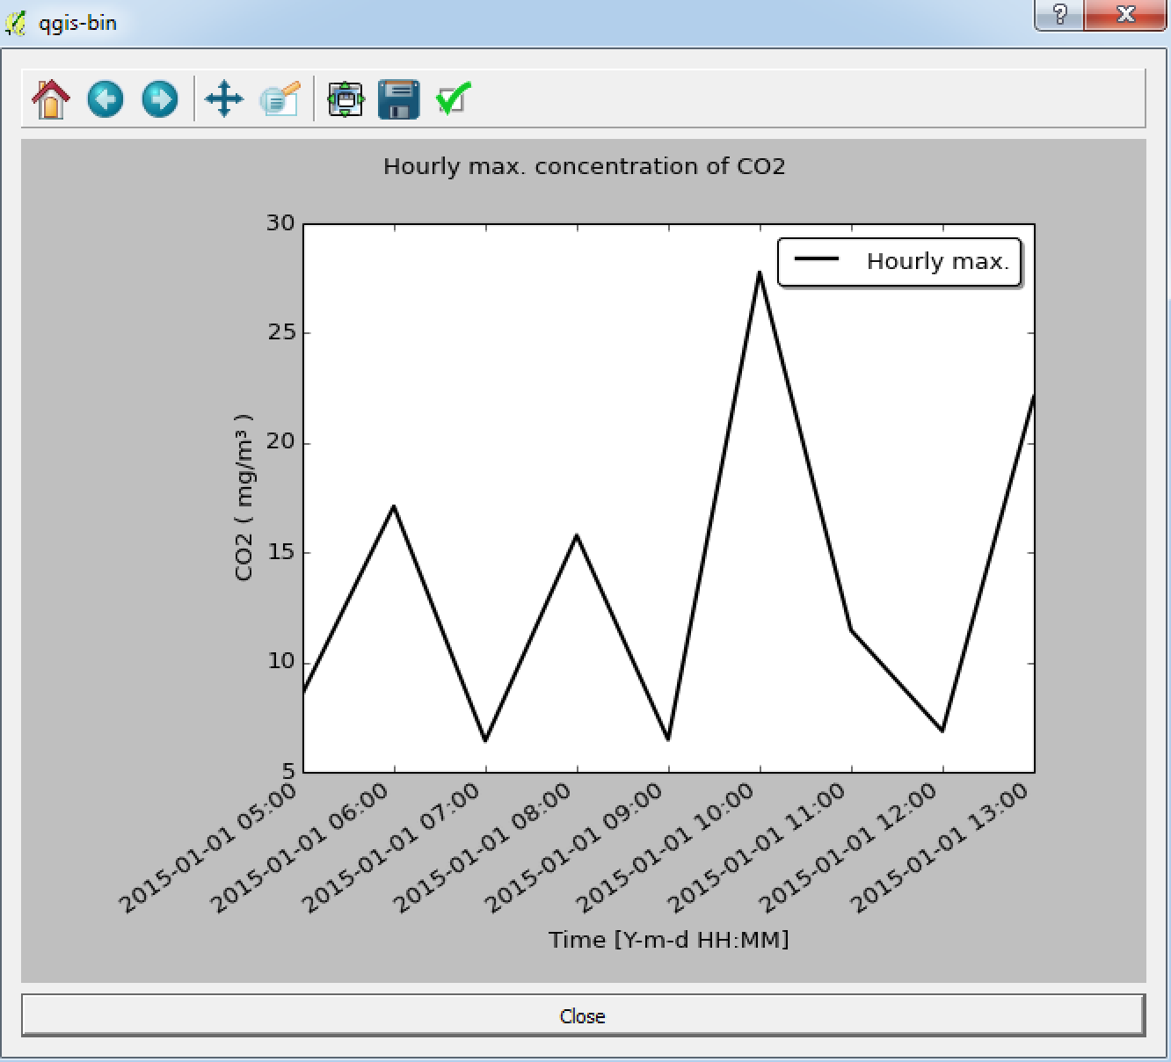

Figure 49: Results of the dispersion simulation for CO2 shown as timeseries (max. value per hour).

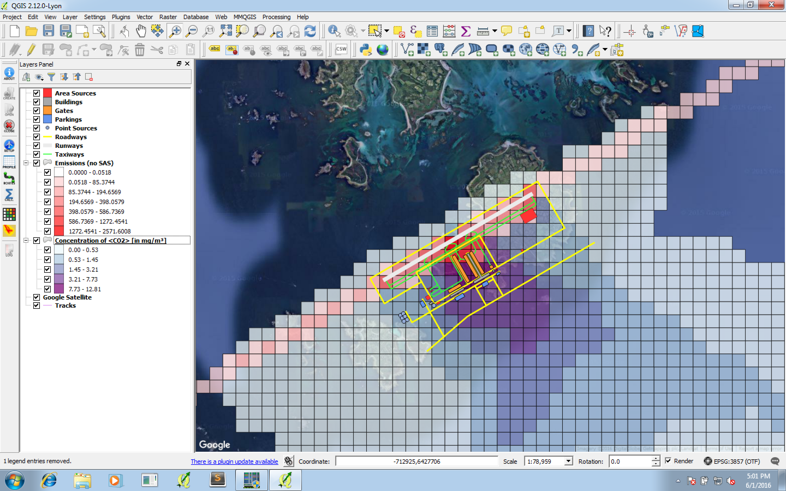

Figure 50: Results of the dispersion simulation for CO2 (mean concentration in mg/m3) shown as vectorlayer. The emissions of CO2 (in kg) calculated with Open-ALAQS are also visible (in red).

# Useful Information

## AUSTAL2000

[AUSTAL2000](http://www.austal2000.de/en/home.html) is the official reference model of the German Regulation on Air Quality Control (*Technische Anleitung zur Reinhaltung der Luft*, TA Luft) and implements the specifications and requirements given therein, in particular in Appendix 3 of the regulation. The model is a Lagrangian particle model in conformance with the German guideline VDI 3945 Part 3. It accounts for several different pollutants, each with specific results, which are strictly bound to the regulations of the German Standard TA Luft 2002 (acc. to European EC Directive 2008/50/EC).

AUSTAL2000 is constantly maintained by the German Federal Agency. Executables (32-bit) are provided for Windows (and Linux), including the complete source code (www.austal2000.de, German/English) which is provided free of charge under the GNU Public Licence.

### Adjustments made to AUSTAL2000

The default version of AUSTAL2000 did not offer 3-dimensional emission grids. Therefore, 3-dimensional emission grids had to be implemented. Moreover, the German Federal Agency agreed to include this modification into the official model AUSTAL2000 version (preliminary version 2.7). As a result, Open-ALAQS will benefit from any official version updates in the future. The new program version will be made publicly available once additional extensions in connection with the current update of TA Luft are finalized (probably towards end of 2016). In the meantime, the extended version 2.7 can be used within Open-ALAQS without restriction.

In version 2.7, grid sources are identified by the new source parameter ***iq***. If larger than zero, the parameter refers to the name of the file (DMNA format, in a source-specific subdirectory) that contains the relative distribution of the emissions from that source over a three-dimensional spatial grid. Each cell of the grid forms a passive volume source. In a typical application only grid sources are applied, one grid source for each pollutant of interest. A grid source includes the emissions of that pollutant from all relevant sources of interest. Both the overall emission (specified by the usual emission rate) and the spatial distribution of that emission in space (specified by an emission grid via index *iq*) are usually time dependent.

### Input data

This section provides a brief introduction to AUSTAL2000 main input data and file formats, and the use of grid sources at hand of a simple example. Further information is provided in the program manual.

All input and output files required for an AUSTAL2000 calculation are located in a directory, the project directory. The necessary input files for a simulation with AUSTAL2000 are:

* **Input file “austal2000.txt”**: Main input parameters except for time series are specified in this text file. Each line contains a parameter definition in the form “*name value*“ where *name* is the parameter name (usually two characters, case sensitive) and *value* is the parameter value, separated from the name by at least one blank. The order of parameters is arbitrary. For floating point values, a decimal point must be used. Some parameters require more than one value, in this case the values are all written in one line, separated by at least one blank. A comment line starts with a minus sign as first character, a comment at the end of the line starts with an apostrophe. An example of this input file is given in **Figure 24**. Parameters are explained in detail in the program manual.
* **Input file “series.dmna”**: All time-dependent parameter values are specified in this file. It must contain at least the time series of the meteorological parameters wind direction (in degrees against north clockwise), wind speed (in m/s), and Obukhov length (in m) in form of subsequent hourly means for an integer number of days. In the data part, the first column specifies the end of the one-hour time interval in the form yyyy-MM-dd.HH:mm:ss. Then must follow (in this order) wind direction, wind speed, and Obukhov length. The order, name, and format of the columns within a data row are specified by parameter form in the file header. Other time-dependent parameters are marked in *austal2000.txt* by a question mark instead of a value and the time series is provided as additional column in file *series.dmna*. In order to address the correct column, the parameter name must be stated in the parameter form in the file header. For source-specific parameters, the column name has the form *source- name*.*parameter_name*. An example of this input file is given in **Figure 25**.
* **Input grid file (eXXXX.dmna):** The grid file is of format *dmna* with a file header and a data part. The data part can be optionally binary and/or compressed; here we assume a simple text format. The file header contains information on the grid and on the data part.
  + **t1:**start of the validity interval (relative time, e.g. 0.00:00:00) or -inf
  + **t2:**end of the validity interval (relative time, e.g. 0.01:00:00) or +inf
  + **dd:** horizontal mesh width in m sk vertical grid (*h*0 *h*1 *h*2 ...), heights above ground in m
  + **mode:** mode the data part( text or binary)
  + **form:** format of data (e.g. Eq%5.1f or Eq%12.5e)
  + **vldf:** type of value (for post-processing, here V for volume value)
  + **artp:** array type description (should be set to M)
  + **dims:** dimension of the data part (for post-processing, must be set to 3)
  + **axes:** type of indices (for post-processing, must be set to xyz)
  + **sequ:** index sequence in which the data values are listed (comma separated)
  + **lowb:** first value of each index (*i*1, *j*1, *k*1, in this order)
  + **hghb:** last value of each index (*i*2, *j*2, *k*2, in this order)

The grid cells are numbered by 3 indices *i*, *j*, *k* with starting value 1. Index *i* refers to the x- direction (west to east), index *j* to the y-direction (south to north), and index *k* to the vertical (lowest to highest layer specified by sk in the file header). The index stated in the index sequence at the very right runs fastest, the one at the very left slowest (C convention). A sequence j-, i+ means that in a data table *i* runs from *i*1 to *i*2 in each row and *j* runs from *j*2 to *j*1 when going down the rows. This means that j-,i+ states that the data are listed in form of a north-oriented map. A sequence k+,j-,i+ means that the first data table is the north-oriented distribution for layer *k* = 1 (height interval *h*0 to *h*1), the second data table is the north-oriented distribution for layer *k* = 2 (height interval *h*1 to *h*2), etc. The sum over all data elements should be 1, because the grid file specifies the relative distribution. However, the data elements are normalized to 1 as well within the program. The horizontal location of the grid is not specified within the file header but by the source coordinates xq and yq which set the lower left (south-west) corner of the lower left grid cell (*i* = 1, *j* = 1). For example, with xq=100, yq=-100, dd=100, sk=0 20 50, the grid cell with indices *i* = 1, *j* = 2, *k* = 2 has the x-extent 100m to 200m, the y-extent 0m to 100m and the z-extent 20 m to 50 m (above ground). The source height hq must be specified in austal2000.txt but it is ignored. An example of this input file is given in Figure 26**.**

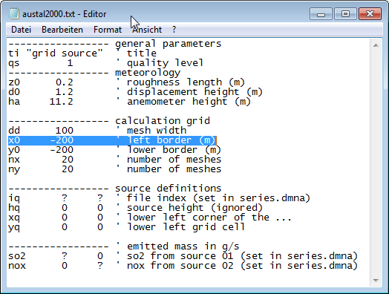

**Figure 51: Example of an austal2000.txt input file**

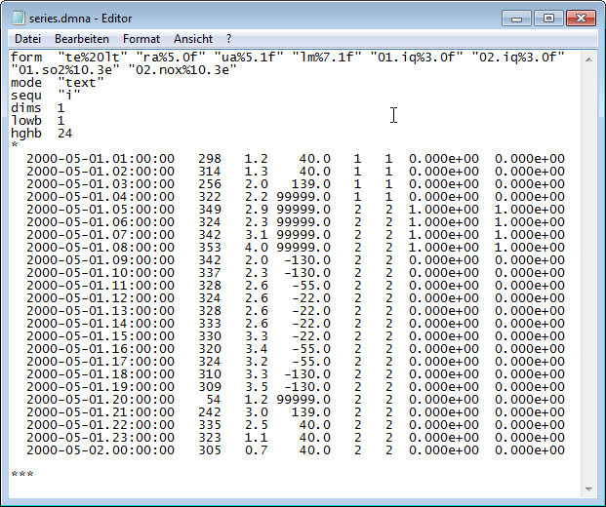

**Figure 52: Example of a series.dmna input file**

|  |  |
| --- | --- |
| D:\p\env\1510-a\notes\talks\e1.png | D:\p\env\1510-a\notes\talks\e2.png |

Figure 53: Example of two grid source file (.dmna) input files

### Start of the dispersion calculation

The program *austal2000.exe* can be started from a DOS shell or executed as an external process from a program. The first argument is usually the project directory. AUSTAL2000 writes a log file into this directory (*austal2000.log*) and provides information on the calculation progress to *stdout* and possibly *stderr*. After the calculation, main results are listed in *austal2000.log* and the concentration distributions are listed in separate files, one for every substance and here one for the concentration and one for the statistical uncertainty of every concentration value.

If existing result files are deleted before the calculation, checking for new result files gives an indication if the calculation has successfully completed. More accurately is to analyze the program output to *stdout* and *sterr*. If the first argument is -D, the program deletes the log file at the start of the calculation, otherwise results are appended to an existing log file.

Hence a program call could read:

“*austal2000 -D work_dir/example”.*

### Output data

AUSTAL2000 calculates the substance-specific output results required by the TA Luft (annual means and possibly daily or hourly means with a given number of exceedings). More precisely, the annual mean is the long-time mean over the time period defined by the provided file *series.dmna*.

In a first step, only the annual mean should be considered. The according file for NOX for example is nox-y00a.dmna (’00’ refers to the grid and will play a role only for nested grids, ’a’ refers to additional load). The file contains the annual mean concentration for each grid cell of the calculation grid (see austal2000.txt) in microgram per cubic meter (see the file header). The data part is by default in text form and north-oriented (see the index sequence).

The statistical uncertainty of every concentration value is provided in the according file, here nox-y00s.dmna. The higher the quality level (parameter ***qs*** in austal2000.txt), the longer the computation time and the smaller the statistical uncertainty. Using 4 times as many simulation particles (qs must be increased by 2) will cause an approximately 4 times longer computation time and reduce the statistical uncertainty by about a factor of 2.

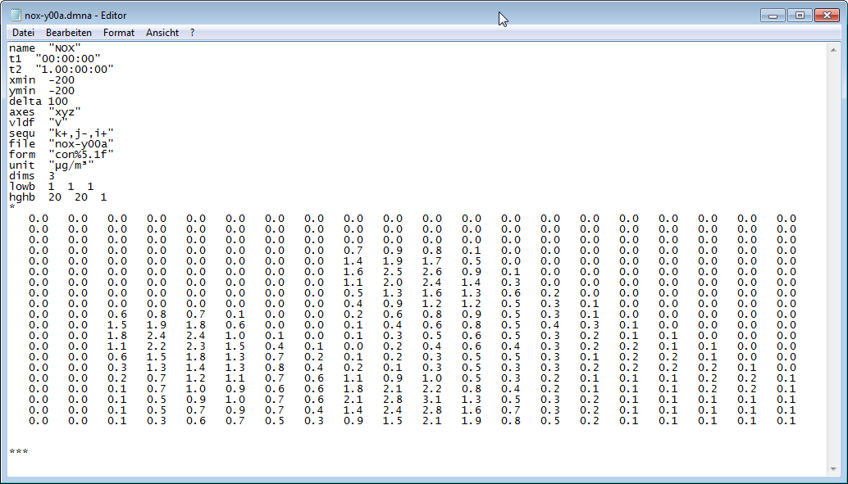

Figure 54: Example of an AUSTAL2000 output file

By default, the concentration file only contains the ground layer (*k* = 1). Using a NOSTANDARD option, more layers can be written out (e.g. with the additional input line ***’os NOSTANDARD;Kmax=3***’ in austal2000.txt).

The DMNA files can be inspected with any text editor. An import and graphical visualization with Excel or a GIS system is straightforward, as the data part is a north-oriented matrix. A free demo version of *IBJdis* (Figure 28), a tool from the LASAT package, can be used, too.

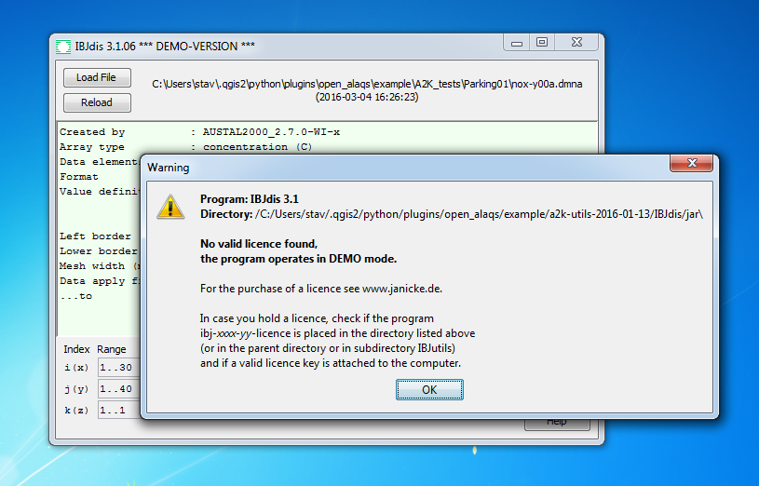

Figure 55: IBJdis demo mode can be used to visualise the output data of an AUSTAL2000 simulation.

## Smooth & shift Approach

### Introduction

The modelling system Open-ALAQS calculates the three-dimensional emission distributions for source groups that are connected to an airport. To apply this output to dispersion models, it is necessary to account in some way for source dynamics like turbulence and momentum of the exhaust from aircraft engines or thermal plume rise.

In order to apply the emission output to a dispersion model without the necessity of addressing every individual source with respect to its dynamics and without the requirement of going into the specific model details, the effects of source dynamics can be included in an approximate way already in the spatial emission distribution. This is done by smoothing and shifting the initial source extent (*smooth* & *shift approach*).

This approach has been used to connect the emission grid provided by the precursor model of Open-ALAQS, ALAQS-AV, to dispersion models. The details are described in the report EEC/SEE/2005/016 by EUROCONTROL. The smooth & shift parameters were derived from LASPORT (version 1.6) which handles the source dynamics in a detailed and explicitly time-dependent manner. The smooth & shift approach forecloses the effects of the source dynamics on the concentration. The further away from the emission, the better is this approximation.

Since 2005 the underlying LASPORT parameter values for describing the source dynamics of main engines have been adjusted. The following describes briefly the new parameters based on the current LASPORT version 2.2.

Finally, we note that the Open-ALAQS "Smooth & Shift" parameters are transparently derived and thus easy to modify. They have been implemented for all airport-related sources, in particular aircraft, GSE, GPU. As regards APU emissions, they are incorporated to aircraft movements. For further details, see the report EEC/SEE/2005/016.

### Default engine parameters

The current LASPORT parameters are defined for three aircraft categories:

|  |  |
| --- | --- |
| **Aircraft Category** | **Aircraft groups** |
| J1 | Small, Medium, Large |
| J2 | Business, Turboprop, Piston, Regional |
| H | Helicopter (Small, Large) |

For an assignment of the various aircraft types to these groups see the LASPORT data base. The LASPORT parameters for describing the source dynamics of main engines are given below:

|  |  |
| --- | --- |
| **Parameter** | **Description** |
| σh | Initial effective horizontal velocity fluctuations |
| σv | Initial effective vertical velocity fluctuations |
| ve | Initial effective exit velocity |
| Ts | Decay time of σh, σv, ve |
| dh | Effective horizontal source extent |
| dv | Effective vertical source extent |
| sv | Effective vertical source shift |

The default parameter values are:

|  |  |  |  |  |
| --- | --- | --- | --- | --- |
| **Parameter** | **Approach** | **Idle** | **Take-Off** | **Climb** |
| **Category J1** | | | | |
| h (m/s) | 1.31 | 0.63 | 2.40 | 2.21 |
| v (m/s) | 0.33 | 0.16 | 0.60 | 0.55 |
| ve (m/s) | 0.0 | 0.0 | 4.0 | 4.0 |
| *T*s (s) | 240 | 240 | 240 | 240 |
| *d*h (m) | 50.0 | 50.0 | 50.0 | 50.0 |
| *d*v (m) | 25.0 | 25.0 | 25.0 | 25.0 |
| *s*v (m) | -100 | 0 | 0 | -100 |
| **Category J2** | | | | |
| h (m/s) | 1.31 | 0.63 | 2.40 | 2.21 |
| v (m/s) | 0.33 | 0.16 | 0.60 | 0.55 |
| ve (m/s) | 0.0 | 0.0 | 4.0 | 4.0 |
| *T*s (s) | 120 | 120 | 120 | 120 |
| *d*h (m) | 25.0 | 25.0 | 25.0 | 25.0 |
| *d*v (m) | 12.5 | 12.5 | 12.5 | 12.5 |
| *s*v (m) | -50 | 0 | 0 | -50 |
| **Category H** | | | | |
| h (m/s) | 0.0 | 0.0 | 0.0 | 0.0 |
| v (m/s) | 0.0 | 0.0 | 0.0 | 0.0 |
| ve (m/s) | 0.0 | 0.0 | 0.0 | 0.0 |
| *T*s (s) | 0.0 | 0.0 | 0.0 | 0.0 |
| *d*h (m) | 25.0 | 25.0 | 25.0 | 25.0 |
| *d*v (m) | 12.5 | 12.5 | 12.5 | 12.5 |
| *s*v (m) | -50 | 0 | 0 | -50 |

### Smooth & shift parameters

In the smooth & shift approach, the horizontal and vertical width *d*h,v is increased to account in addition for the dynamical effects of σh,v. The result is the description of the aircraft emission by a line source with increased horizontal extent *D*h and increased vertical extent *D*v.

At take-off for example, the lower edge of the non-smoothed line source is at the ground and the upper edge is at height *d*v. After lift-οff for example, the lower edge of the line source is at *z*(*x*) and the upper edge at *z*(*x*) + *d*v.

With smooth & shift, the vertical line extent is *D*v. After lift-οff (and at approach), the increased vertical extent of the line source should be symmetrical to the original line extent. This is achieved by increasing the vertical down-shift by the amount (*D*v *d*v)/2.

Following the formulas described in report EEC/SEE/2005/016, the resulting source parameters for the smoothed & shifted, passive sources read:

|  |  |  |  |  |
| --- | --- | --- | --- | --- |
| **Parameter** | **Approach** | **Idle** | **Take-Off** | **Climb** |
| **Category J1** | | | | |
| *D*h (m) | 390 | 190 | 720 | 660 |
| *D*v (m) | 100 | 50 | 180 | 170 |
| *s*v (m) | -138 | 0 | 0 | -173 |
| **Category J2** | | | | |
| *D*h (m) | 200 | 100 | 360 | 330 |
| *D*v (m) | 50 | 25 | 90 | 80 |
| *s*v (m) | -69 | 0 | 0 | -84 |
| **Category H** | | | | |
| *D*h (m) | 25 | 25 | 25 | 25 |
| *D*v (m) | 12.5 | 12.5 | 12.5 | 12.5 |
| *s*v (m) | -50 | 0 | 0 | -50 |

The corresponding three-dimensional, extended line emissions must be mapped onto the three-dimensional emission grid of Open-ALAQS.

### Demonstration

The possibility to account for source dynamics has been added to the “Emissions Calculation” tab which can be found in the “Result Analysis” window as shown in Figure 29. In order to demonstrate the implementation of the smooth and shift approach in Open-ALAQS an example is presented below for taxiing emissions of a single aircraft.

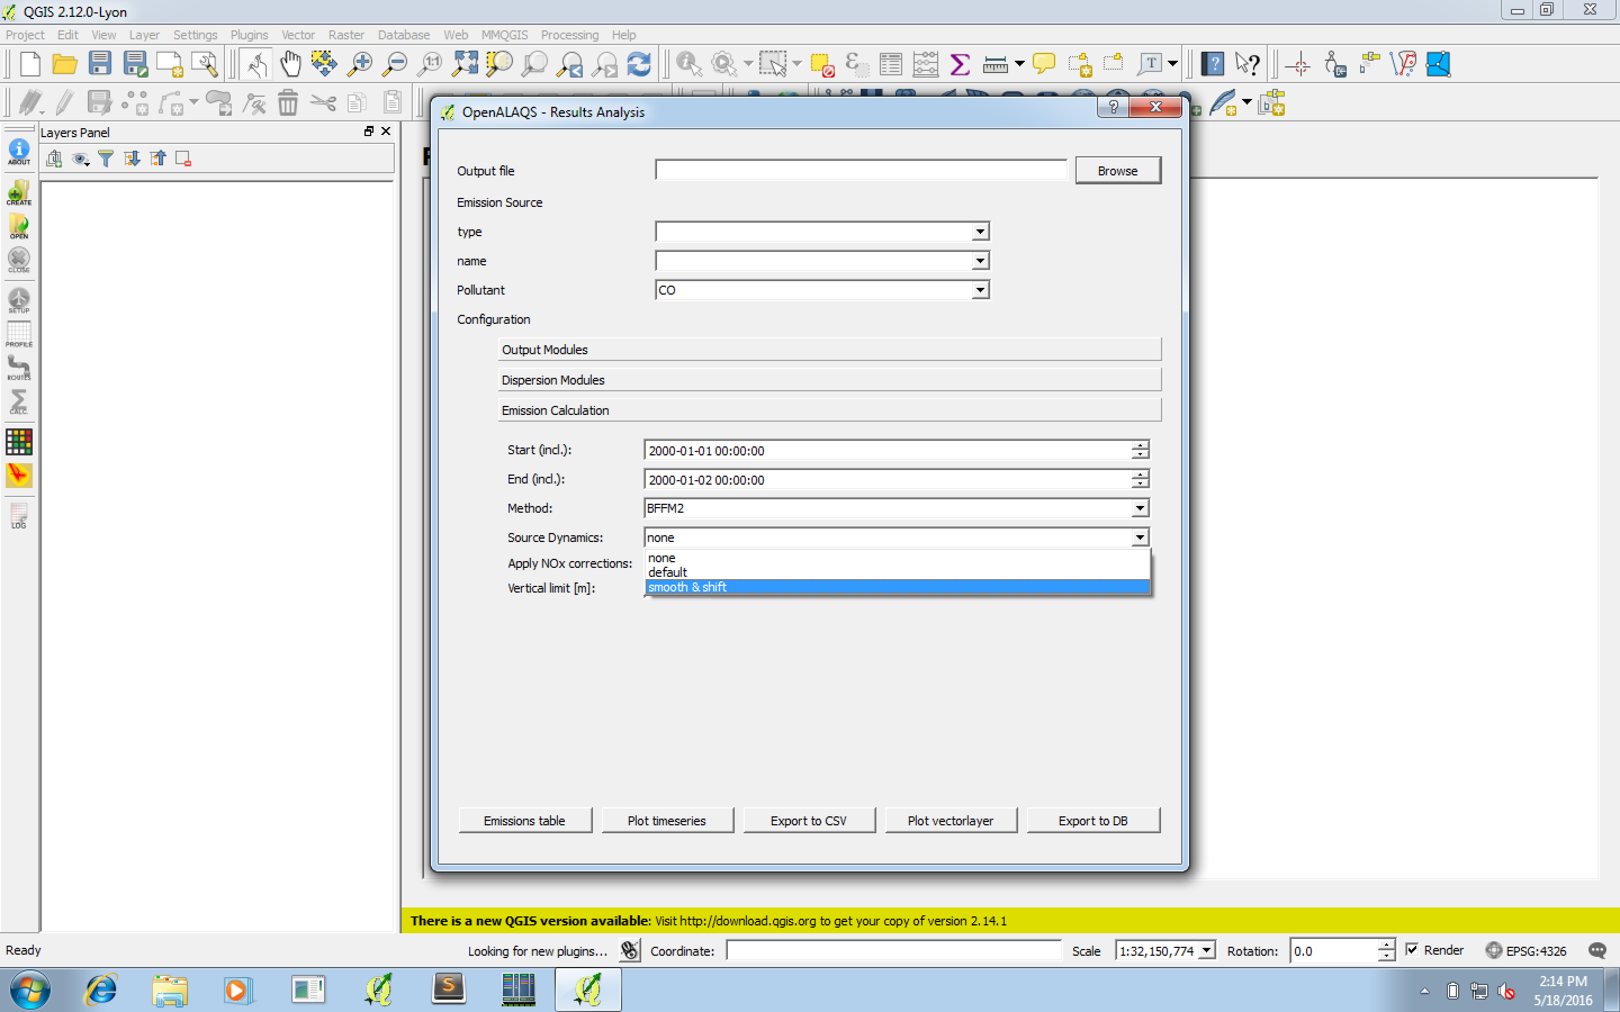

Figure 56: Open-ALAQS “Result Analysis” window. The option “Source Dynamics” has been added to the “Emissions Calculation” tab.

The trajectory of the aircraft in the taxiway is presented in Figure 30. The taxi route can be broken down to several segments. The initial geometry of each segment is a straight line. The first step in applying the smooth and shift approach is to expand each segment so that each line is converted to a polygon according to the effective horizontal source extent. Then, height is added to each polygon in order to account for the effective vertical source extent. The result of this geometrical transformation is presented in Figure 30. It is important to highlight the fact that the curvature of the Earth’s surface is taken into account in all calculations.

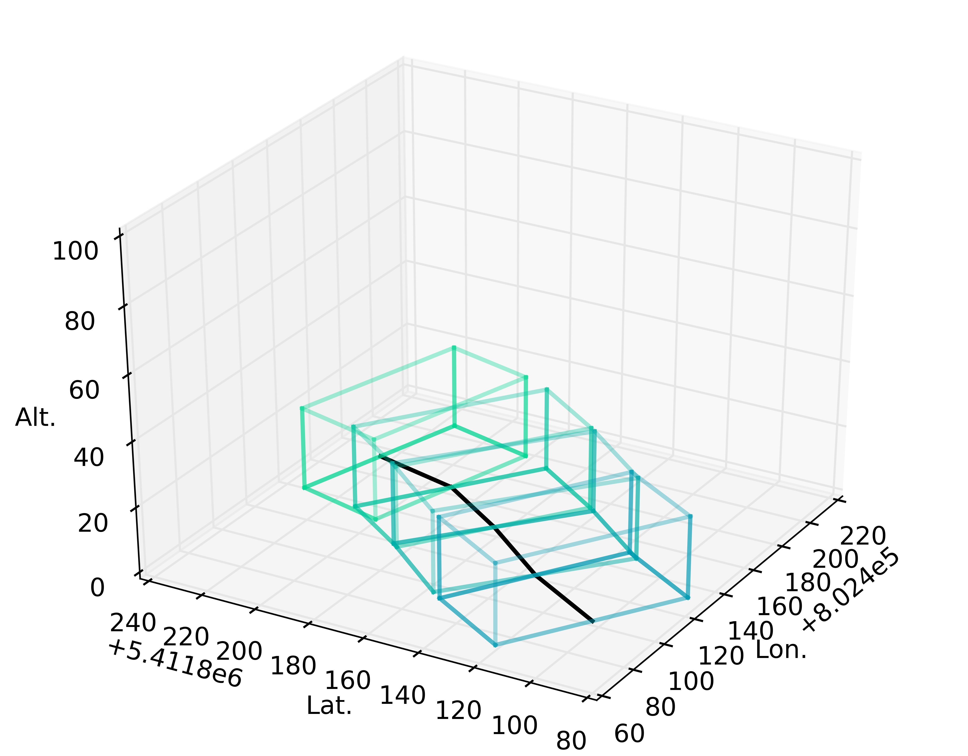

Figure 57: Demonstration of the change in the geometry of taxiing emissions. Each segment of the taxiway (black line) is expanded into a polygon to account for source dynamics.

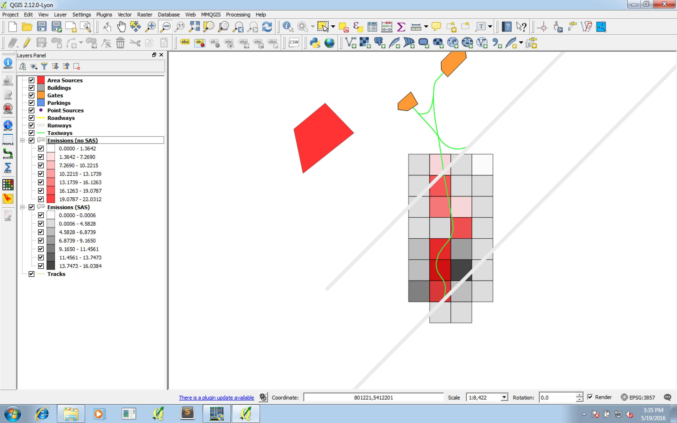

Figure 58: CO2 emissions from taxiing for a single aircraft movement before (in red) and after (in grey) accounting for emission dynamics.

## Runways Orientation and dimensions

Runways are named by a number between 01 and 36, which is generally one tenth of the magnetic azimuth of the runway's heading in degrees: a runway numbered 09 points east (90°), runway 18 is south (180°), runway 27 points west (270°) and runway 36 points to the north (360° rather than 0°).[1] When taking off from or landing on runway 09, a plane would be heading 90° (east). However, runways in North America that lie within the Northern Domestic Airspace of Canada are numbered relative to true north because proximity to the magnetic North Pole makes the magnetic declination large.

Note that wind direction is given in an opposing way; a plane taking off from runway 09 would be going the exact opposite direction of a wind blowing from due east (090 degrees).

A runway can normally be used in both directions, and is named for each direction separately: e.g., "runway 33" in one direction is "runway 15" when used in the other. The two numbers always differ by 18 (= 180°).If there is more than one runway pointing in the same direction (parallel runways), each runway is identified by appending Left (L), Center (C) and Right (R) to the number to identify its position (when facing its direction) — for example, Runways One Five Left (15L), One Five Center (15C), and One Five Right (15R). Runway Zero Three Left (03L) becomes Runway Two One Right (21R) when used in the opposite direction (derived from adding 18 to the original number for the 180 degrees when approaching from the opposite direction).

1. Further information about QGIS (LTR v2.8.4):

   *A gentle introduction to QGIS*: <http://docs.qgis.org/2.8/en/docs/gentle_gis_introduction/index.html>,

   *User Guide*: http://docs.qgis.org/2.8/pdf/

  